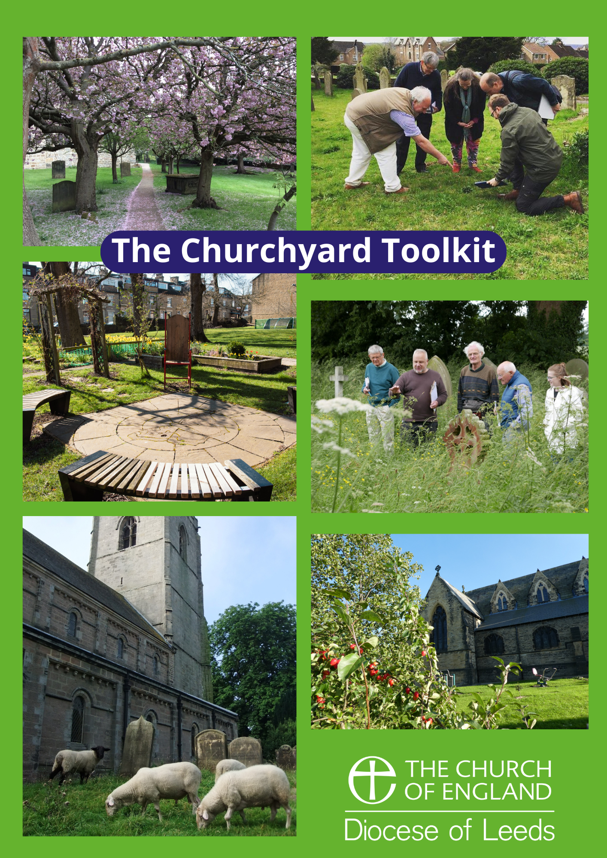
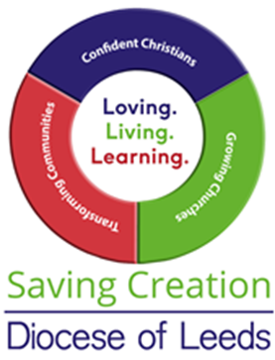
The Churchyard Toolkit –
Six P’s for Fruitful Churchyard

Contents
Who and what is this toolkit for? 2
Churchyards Bringing Hope 3
The Six P’s for a Fruitful Churchyard 4
We want to use the churchyard as a…
Educational Resource 7
Energy Hub 8
Family Friendly Space 9
Heritage Hub 10
Productive Garden 11
Quiet Garden 12
Recreation Space 13
Tree Grove 14
Urban Oasis 15
Wildlife Habitat 16
Worship Space 17
Resources 18
Appendix A - Further Details on Permissions 19

Who and what is this toolkit for?
This toolkit is designed for anyone who has responsibility for, or uses, their local churchyard and would like to make this God given space more fruitfully as part of the church’s mission to safeguard the integrity of creation and share the good news of Christ’s renewal of all things.
You know your churchyard and its locality. Churchyards and church land can be very different in nature and context from small areas of mainly paving, to expanses of graveyards or grasslands and trees. Each one has the potential to be cherished and to serve the church and the wider community.
What opportunities lie ahead for your churchyard? Could it be: an outdoor worship space; a small oasis of green in an urban context; a local community veg growing hub; a wildlife haven; a tourist destination for heritage graves; a woodland area for carbon capture; a space to generate electricity for the church or community; or more climate resilient space with trees providing shade and slowing the flow in heavy rainfall events?
We hope this toolkit inspires you and gives you a set of steps and guidance on the journey to make the most of the gift that is your church land.
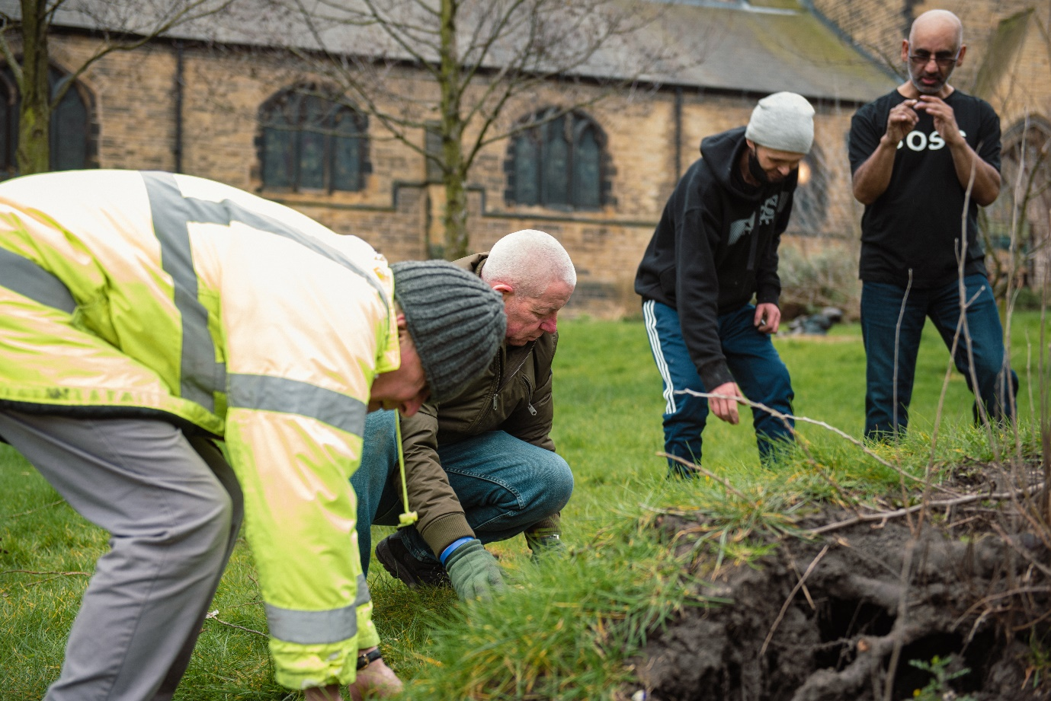

Churchyards Bringing Hope

The earth is the Lord’s, and everything in it, the world, and all who live in it.
Psalm1:24

Created
The 1773 Enclosure Act firmly established private ownership of land in England, with publically owned and managed ‘commons’ now being rare. It’s not surprising then that culturally we may have forgotten that land belongs, not to us personally or in the case of our churchyards to the church, but to God. Indeed all of the natural world has been created by God, through Christ, in order to worship and glorify him¹ - including the stones, water, air, soil, plants and all creatures we find in our churchyards.

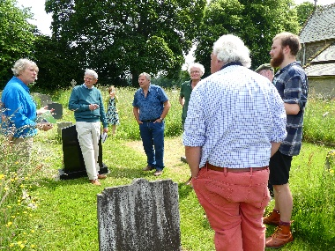
Covenanted
Through a series of covenants we have been invited to partner with God in looking after the land, of which are churchyards are an obvious starting point (alongside your own gardens, if you are privileged to have one).

When God made his covenant with Moses on Mount Sinai he included a whole series of instructions for his people about how to take care of the land². Fallow years and Jubilees were to ensure that the Israelites did not exhaust the soil and the richness of biodiversity was maintained. All the details which ensured justice for people and planet are essentially the terms conditions of these partnership arrangements, which if broken have consequences spelt out by Isaiah³. We see these same consequences around us today with decline and extinction of plants and animals, air and water pollution, soil contamination and climate breakdown.

Commissioned
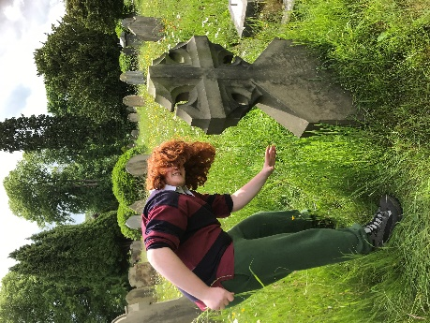
Jesus’ death and resurrection brought in a new covenant⁴ for the redemption of all people and all creation. With this came a recommissioning for his followers and humanity: to bring the good news of his renewal to all of creation⁵. Being this good news, bringing the Kingdom of God to earth, involves establishing justice and healing for the whole of creation – people and the land.

As Christ’s hands and feet on earth we can start this work in our churchyards whether that is though, for example, nurturing wildlife spaces, creating spaces of welcome where local people can receive revitalisation in the outdoors, or planting trees to clean the air.

While many of our churchyards are places where we remember and respect the dead, they can also be places of life and joy and hope. Places of refreshment for many people who have limited access to green spaces. Places of hope at a time when we face the twin challenges of biodiversity and climate crisis. Our church land belongs to God, can it demonstrate what Christ’s restoration for all people and all of creation can be like?
1. Genesis 1, Psalm 148, Psalm 150:6, Proverbs 8:30-31, John 1:3, Colossians 1:15-17, Hebrews 1:1-2
2. Leviticus 25
3. Isaiah 24:4-6
4. Hebrews 12:22-24, Colossian 1: 19-20
5. Mark 16:15
The Six P’s for a Fruitful Churchyard
- People and Partnership
  - Building a team
- You may already have a Green Team or Gardening Group willing to take on management and maintenance of your churchyard. If not, is there an enthusiastic member of the congregation willing to build a team?
- Tell people what you would like to do and ask for volunteers – announcements at services, notice board, website, and social media.
- Find out whether there are experts in the congregation and parish (eg botanists, field naturalists, local historians) willing to help. Get ideas from your children and young people.
  - Communication to the whole church and the community
- The PCC is ultimately responsible for maintenance of the Churchyard so it is important to provide them with regular updates. It would help communication if one or two of the group were also PCC members. It is also important to listen to any guidance the PCC may offer.
- Keep the congregation informed and ask for suggestions.
- Talk to people who visit the churchyard. Many local people may view the churchyard as “theirs” and be willing to help enhance it.
- Engage with any local residents’ groups and parish council (if there is one).
  - Partnerships – local school, other community groups, “Friends of”
- If your churchyard is managed by the Local Authority, how can you work together with them? Start a conversation.
- Consider partnering with the local school, residents’ groups or the local history society. Establishing a “Friends of…..” group may be a useful vehicle for fundraising as well as involving non-churchgoing parishioners.

- Prepare
  - Assess what land you have and what is already there
- Churches’ Count on Nature. Undertake a survey of the species in your churchyard.
  - Expert advice
- Are there members of your congregation who can help with plant identification and other wildlife surveys?
- Is your parish within the Yorkshire Dales National Park or the Nidderdale Area of Outstanding Natural Beauty (AONB)? If so, contact the Wildlife Conservation Officer in the National Park or the Biodiversity Project Officer in the AONB. Your churchyard may be part of an important habitat for certain species.
- Contact the Diocesan Biodiversity Advisor for help with other sources of expertise.
  - Assess the needs of your local community
- Community data. Find out if your community is in an area of nature deprivation on the Friends of the Earth Access to Green Spaces Map
- Community surveys. Conduct a survey of local residents to find out what their needs are for outdoor space, nature connection and social interaction.
  - Use the Eco Church land criteria to help you assess what you have and check out the wealth of church land resources on the Eco Church website.
  - Research
  - Outreach and Mission
Explore ways in which to use your land could support wider mission. For example Forest Church, Muddy Church or Outdoor Church, involving children and young people in creation care/discipleship.
  - Caring for God’s Acre
Caring for God’s Acre is a national charity that promotes the conservation of churchyards and burial grounds and supports the volunteers who look after them. It has a wealth of free downloadable information on its website.
  - C of E webinars
Get inspired and find help with biological recording, how to manage your grassland, find your faith in trees, hear from the Church Commissioners, learn about bats, growing food and faith, and far more.

- Plan
  - Overall Strategy – setting a vision
Once you have a team and you have assessed what land you have, what is already there and the needs of your congregation and local community it’s time to discern your vision. Work with your PCC on this so that it aligns with the whole mission and life of the church.
- Specific Churchyard Management Plan.
- What would you like to see happening in the churchyard in two, five or ten years’ time?
- Write a detailed plan to cover action required, who will undertake this and when, costs and permissions required. If your churchyard is large, plan for different zones for different areas of your mission.
- Template plan.
A template Churchyard Management Plan accompanies this toolkit to help get you started.

- Permissions
  - PCC Approvals
- Always keep the PCC informed and get its approval for your vision for the churchyard and Churchyard Management Plan. You will also need the PCC’s approval to support List B and Faculty applications (see below). You may be required to seek the approval of your Church Architect on churchyard specific works, so keeping them up-to-date is also important.
- If you are working in partnership with other organisations, make sure you have clearly defined roles and the PCC retain ownership and control of your land. If you need advice check with the Diocesan Mission and Pastoral Team.
  - DAC approvals
- Churchyards are governed by the faculty jurisdiction rules and any proposed changes to them will require different levels of permission from either the Archdeacon (List B permission) or the Chancellor (faculty permission). The Church Buildings team can provide advice on all other types of work.
- By consulting at an early stage, the DAC can help you understand the rules and get the right permissions to support your churchyard project.
- A number of small changes (List A permission) suitable for your church and churchyard are easy to implement and do not require consultation or written permission. This may range from the lopping or topping of a tree that is dying, dead or has become dangerous, to the introduction of temporary, small signage.
- See Appendix A for more details on help with permissions for Tree Works, Paths and Signage.
  - Local Authority approvals
- If your churchyard is located within a Conservation Area you will need your Local Authority’s approval for any work to trees
- For “Closed Churchyards” See Appendix A

- Pennies - Funding
  - If your congregation and local community are inspired by your vision for the Churchyard, you may not have to look any further for funding.
  - There is advice and a number of grant funding sources for biodiversity, community projects, and tree planning and heritage projects on the diocesan funding page.
  - When seeking funding remember to be clear about what the outcomes of the project will be and how it will benefit local people and/or wildlife.

- Party - Celebrate and Review
  - Tell your story
  - Make sure you provide good signage in your churchyard. Visitors need to understand what they can see and how they can access it. Find signage advice at Caring for God’s Acre.
  - Share your success with the diocesan communication team, the wider community on social media, through the local press. You could even hold a special event in your churchyard to share what you have achieved.
  - Eco church
- Register and apply for an Eco Church award.
  - Churches’ Count on Nature and/or the Great Yorkshire Creature Count
    - Undertake the survey annually and celebrate when the number of recorded species in your churchyard increases.
  - Review
    - Reflect on your vision and Churchyard Management Plan annually. What is working well? What barriers need to be overcome? What is the next step for your life of your church in the churchyard?

We want to use the churchyard as a…
Educational Resource
Where would this work?
- Your churchyard has features that make it an interesting outdoor classroom eg open space, biodiversity, gravestones, geology, veg beds
- You are located close to a school
- Your local school lacks outdoor space/a wildlife area etc
What benefit will it bring?
- An opportunity for local children/young people to connect to the church
- Build relationships with a local school
- Children may be able to help with some maintenance tasks and bring fresh ideas
- You may be able to attract funding for schools activities

Some ideas to consider
- Use one of the curriculum activity ideas from the Caring for God’s Acre Education Pack
- Discuss with the head teacher what your churchyard could offer the school
- Create resources that can be used by home schooled children
- Children could plant fruit trees or bushes and watch them produce fruit
- Older young people could help prune trees
- Create bug hotels or places for insects
- If you have raised beds, school could take over responsibility for one
- Involve school groups in your annual Churches count on Nature

Keep in mind
- Consider safeguarding and health and safety when inviting schools groups to the churchyard
- Facilities such as hand washing and toilets
- Who will be needed from the church to host the school group?

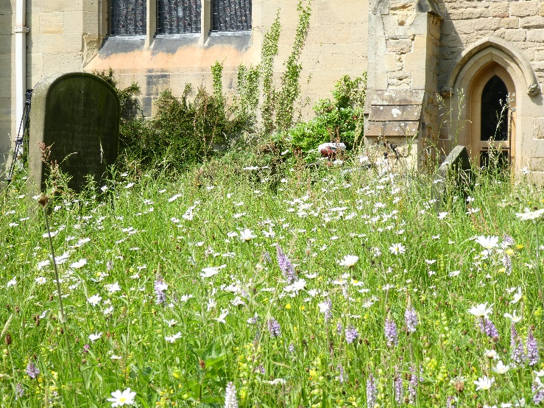
Energy Hub
Where would this work?
- Where you are seeking to reduce your carbon emissions
- Larger churchyards with space, which has not been and will not be used for burials
- With small areas of burial-free space, vertical GSHPs may be feasible (though expensive). Horizontal GSHPs might be feasible where larger burial free space.
- South-facing areas for ground-mounted solar photo voltaic panels which are sheltered from the wind and sheltered from view from outside, but not from the sun and with access secured from the public
- In churches or church halls where the roofs are not suitable for installation of solar PV for structural or heritage reasons

What benefit will it bring?
- Reduce electricity bills for the church and local community
- Potential to work in partnership with the local community and local authority
- You may be able to attract funding

Some ideas to consider
- Install a small wind turbine
- Install electric car charging facilities
- Partner with neighbouring properties to sell your electricity when you are not using it
- Install a ground-mounted solar array, for example a seasonably angle-adjustable array

Keep in mind
- Planning and DAC permissions will be needed
- Impact of neighbours such as noise, shading and traffic
- Insurance: some companies regard ground-mounted systems as more liable to damage or theft
- Ownership of the equipment
- Maintenance

Family Friendly Space
Where would this work?
- You are in an area where lots of families live, but lacks safe outdoor community spaces
- You have or can create a safe space in the churchyard
- You have a children or youth worker or volunteers who can work with families

What benefit will it bring?
- The opportunity to engage with families in the wider community
- Build partnership with local organisations such as toddler groups, youth groups, Scouts
- The opportunity for church families to spend time together
- Some families may be willing to help maintain the space
- You may be able to attract funding for family activities or equipment

Some ideas to consider
- Invite families for events such as picnics
- Create a safe play area for young children (mud kitchen etc)
- Create bug hotels
- Plant fruit bushes/strawberries for children to pick and eat
- Partner with other organisations that work in outside space with families such as Forest Schools
- Hold a ‘pop up farm’ or insect day
- Start a Muddy Church or Forest Church

Keep in mind
- Consider safeguarding and health and safety when inviting families into the churchyard
- Facilities such as hand washing and toilets
- Permissions will be required for fencing, play equipment
- Insurance for family events
- Maintenance
- Publicity

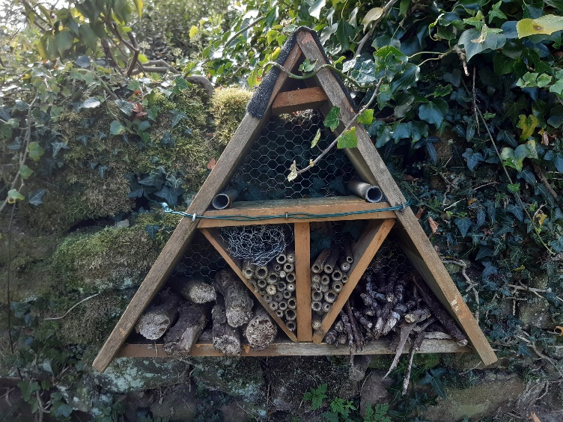
Heritage Hub
Where would this work?
- Where you have interesting headstones or monuments
- You are in a wider historic area
- You have found ancient artefacts
- You have a local historian or history group
- You already get enquiries about the history of the church or churchyard
What benefit will it bring?
- Wider interest in the historic environment of the church
- It could provide an opportunity to engage with other community groups
- You might be able to attract funding from heritage groups
- You may generate interest in starting a “Friends Group” or other support for your church
Some ideas to consider
- Create a marked heritage trail
- Install interpretation boards to highlight key features
- Have a churchyard visitors book (this could be online)
- Guided talks of the churchyard
- Invite your local school (see also Educational Resource)
Keep in mind
- Further guidance is available from Caring for God’s Acre
- Permissions will be required for interpretation boards and the introduction of other churchyard features. The Church Buildings Team can advise on permission.
- Consider health and safety when inviting people to tour the churchyard
- Publicity

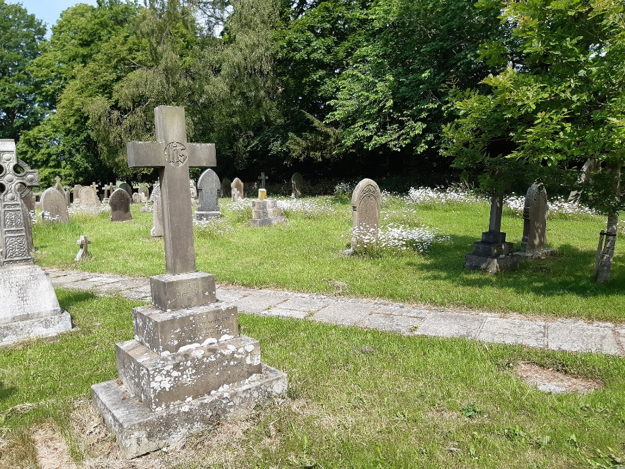
Productive Garden
Where would this work?
- You are in an area where few homes have gardens
- There are unmet mental health needs in your congregation or community
- Food poverty and/or poor diet are an issue locally

What benefit will it bring?
- Connecting with local people
- Connecting people with creation
- Helping to improve mental health
- Potential partnership working with a local health provider
- You may be able to attract funding for gardening equipment

Some ideas to consider
- Create a “help yourself” herb garden or fruit bushes/trees
- Install raised beds for easier access and a shed to store tools
- Grow veg for a food bank or pay as you feel café
- Partner with a local allotment association
- Work with a partner organisation such as your local GP or Groundwork to provide green social prescribing
- Host a Men’s Shed
- Run and after school gardening club or involve local schools

Keep in mind
- Permissions will be required for raised beds, sheds and signage
- Consider health and safety for gardening
- Consider safeguarding when inviting vulnerable adults or children into the churchyard
- Signage for what to pick when
- Publicity

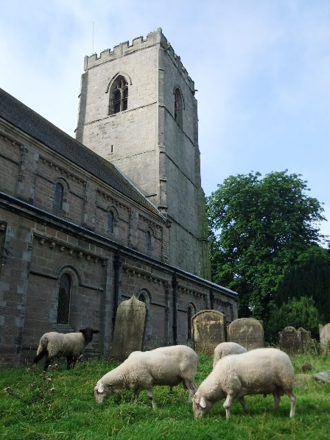
Quiet Sanctuary
Where would this work?
- Churchyards away from excessive road noise
- Churchyards in pedestrianised town centres with plenty of footfall
- Churchyards in areas with many tourists
- Churches where there is already some link to a contemplative network, e.g. WCCM or Julian Group
- Churches whose congregations go on silent retreats

What benefit will it bring?
- More opportunity for the congregation and wider community to connect with God
- Familiarity with contemplative prayer, which is valued across interfaith and ecumenical borders
- Wellbeing and mindfulness

Some ideas to consider
- Create a quiet area with seating and features for reflection such as sensory plants, water features, bird table
- Include signage that includes scripture and suggestions for reflection
- Create a labyrinth by mowing grass paths or with stone boarders
- Create a marked reflection trail in a larger churchyard
- Join the Quiet Garden movement

Keep in mind
- Permission will be needed for benches, fountains and paths
- Publicity

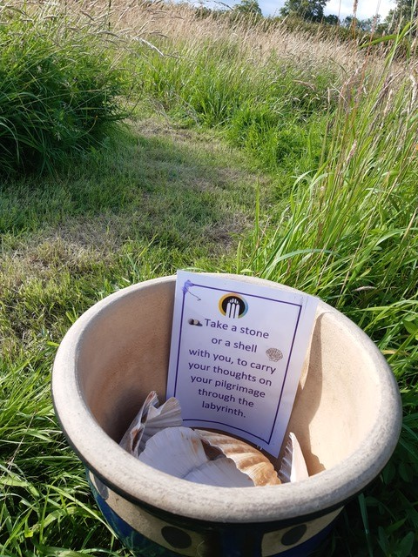
Recreation Space
Where would this work?
- You have little community recreation space in your area
- You have burial free space
- There is a local need for specific groups

What benefit will it bring?
- Opportunities to welcome and engage with your community
- Improved wellbeing
- You may be able to attract funding

Some ideas to consider
- Install an outdoor gym with exercise equipment
- Create mown open space for ball games
- A secluded recreational space eg for Muslim women
- A bush craft space for Scouts

Keep in mind
- Permission will be needed to install equipment
- Maintenance
- Consider safeguarding and health and safety when inviting schools groups to the churchyard
- Ball games do not damage the church windows!
- Publicity

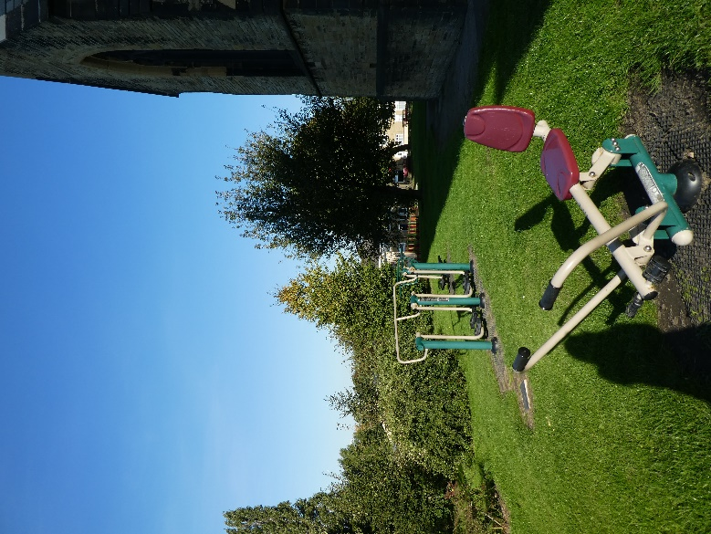
Tree Grove
Where would this work?
- A larger churchyard with a burial free space
- Where there are smaller spaces or potential for a hedge or hedgerow trees

What benefit will it bring?
- Potential to increase biodiversity and wildlife
- Slow the flow of intense rainfall and reduce flooding
- Provide shade and cooling in heatwaves
- Capture and store carbon emissions
- Opportunities for community engagement, wellbeing and worship space
- You may attract funding for tree planting

Some ideas to consider
- Plant an orchard
- Plant for a woodland worship space
- Seek advice from organisations like the Woodland Trust

Keep in mind
- Choose tree species with care – plant the right trees in the right place
- Further guidance on is available from Caring for God’s Acre
- Help and advice is also available from the Yorkshire Wildlife Trust
- Permissions will be needed
- Health and safety for tree planting
- Maintenance

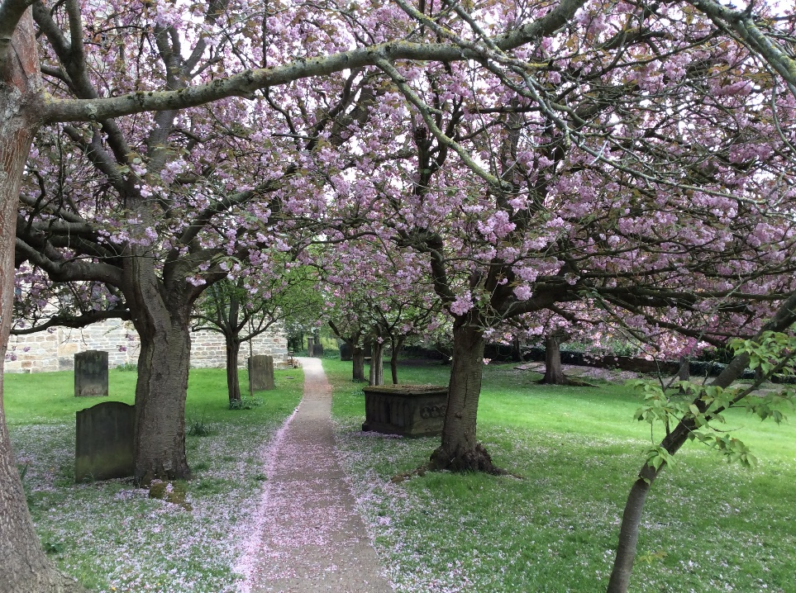
Urban Oasis
Where would this work?
- Where you have limited churchyard space which are mainly hard surfaces
- You are in an area with few green spaces
- You already have connections in the community eg GPs who are looking for social prescribing opportunities

What benefit will it bring?
- Improved creation connection
- Opportunities for welcoming your wider community
- Mental wellbeing benefits for your congregation and wider community
- Habitat for pollinating insects
- You may be able to attract funding for planting

Some ideas to consider
- Create one or more floral beds or planter with spring bulbs, summer annuals and autumn colour. Provide seating nearby.
- Create a “help yourself” herb planter
- Grow a green wall with climbing plants to cover an unsightly or dull surface.
- Make a small “bug hotel”
- Encourage children to help with planting and maintenance

Keep in mind
- Permissions will be needed for benches and new planters

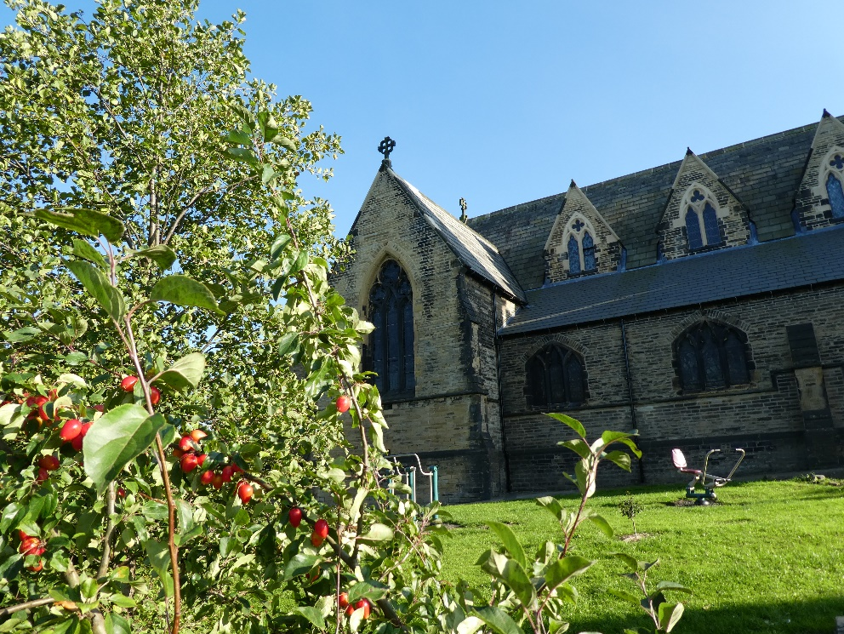
Wildlife Habitat
Where would this work?
- In a large churchyard with areas of older unvisited graves
- You already have people visiting the churchyard to appreciate the plants and animals
- You have a biodiversity expert or interest in the congregation or community

What benefit will it bring?
- A contribution to creation restoration
- A space for creation appreciation
- Potential to partner with local wildlife groups
- You may be able to attract funding from wildlife funders

Some ideas to consider
- Create a wildlife zone in part of your churchyard
- Install information boards to highlight the biodiversity of and the species seen in the churchyard
- Use signage to explain to visitors how the churchyard is being managed for wildlife. It is especially important to explain why some areas of grass and undergrowth are being left uncut to try to forestall complaints that parts of the churchyard are untidy and not being cared for
- Install a bug hotel, bird, bat, hedgehog boxes
- Create a self-guided wildlife trail and leaflet accessed via a QR code and smart phone
- Hold events such as bug hunts, flower identification, bird or bat watching, or skills training such as scything or willow weaving workshops

Keep in mind
- Wildlife areas do require specific maintenance
- Further guidance on is available from Caring for God’s Acre
- Help and advice is also available from the Yorkshire Wildlife Trust
- Permissions will be required for interpretation boards, bird boxes, bat boxes
- Permissions may be needed for signage (see Appendix A)
- Bug hotels will require consultation with the DAC
- Talk to the council if they maintain the churchyard so they do not mow or use insecticide
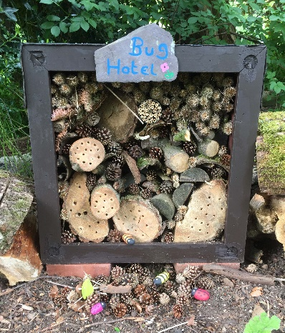

Worship Space
Where would this work?
- Where you have space for a group to gather (away from road noise)
- You already have congregation members who like being outside
- You already have community interested in informal worship
- You have active links with other like-minded local churches
- You have active links with young people in Christian groups

What benefit will it bring?
- Enhanced worship joining with all creation
- More accessible worship for some in your wider community
- Potential for worship that is suitable for all ages
- Opportunities for more kinaesthetic (active) worship
- Equipping the congregation with everyday outdoor worship skills
- Opportunities to engage young people in worship leading
Some ideas to consider
- Use the Agricultural Year or Celtic Festivals as a focus for your worship
- Include short activities that make the most of the space you are in
- Start a Forest Church with worship accessible to your un-churched networks
Keep in mind
- Access needs for all
- Check permissions with your Bishop for outdoor Eucharistic worship
- Consider health and safety
- A wet weather plan
- Publicity
- See also the Church of England Outdoor Worship Guidance

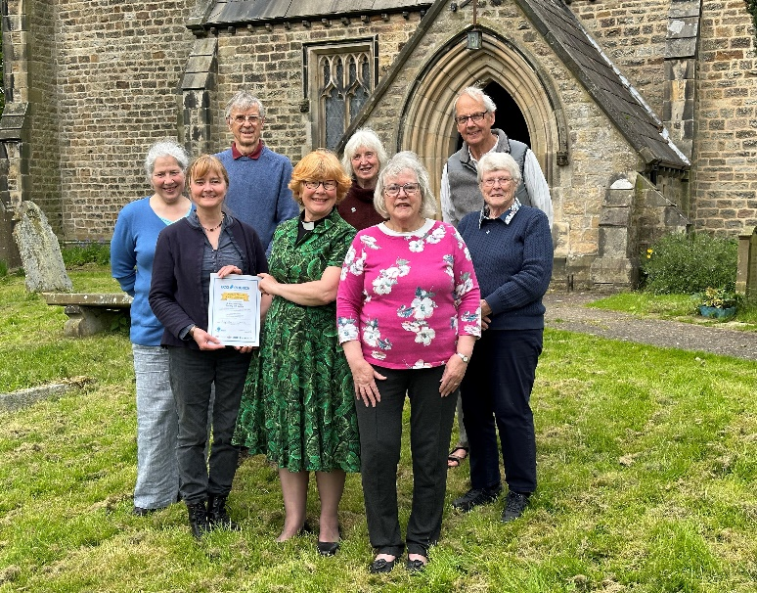
Resources for Parishes
More detailed advice is available on the environment pages of the diocesan website www.leeds.anglican.org/our-faith/environment/resources-for-my-church/churchyards/ . If you need further advice on the Churchyard Toolkit contact the Diocesan Environment Officer who will put you in touch with one of the Diocesan Environment Group advisors.

- Caring for God’s Acre: resources and advice www.caringforgodsacre.org.uk/
- Diocese of Leeds DAC Environmental Policies and Guidance – including Churchyard biodiversity, trees and paths/hardstanding www.leeds.anglican.org/how-we-can-help/dac/environmental-sustainability/dac-sustainability-policy/
- Land and Nature CofE webinar series recorded www.churchofengland.org/about/environment-and-climate-change/recordings-webinars-land-and-nature-churches-count-nature and as a YouTube playlist www.youtube.com/playlist?app=desktop&list=PLcc_HT5TeqjpwXmnMDjMyC1-dbeZPCJOK&mc_cid=caaa6a315c&mc_eid=520498abd7&cbrd=1
- Case Studies: C of E Biodiversity www.churchofengland.org/about/environment-and-climate-change/our-stories
- Churches Count on Nature – annual recording of species www.caringforgodsacre.org.uk/get-involved/love-your-burial-ground-week/
- Great Yorkshire Creature Count (Yorkshire Wildlife Trust) www.ywt.org.uk/GYCC
- C of E Biodiversity Guidance www.churchofengland.org/resources/churchcare/advice-and-guidance-church-buildings/biodiversity
- C of E Trees Guidance www.churchofengland.org/resources/churchcare/advice-and-guidance-church-buildings/trees
- Find your churchyard on the NBN Atlas map (if it has been mapped it will appear on this map, and you can link your records to it) https://burialgrounds-places.nbnatlas.org/search?q=#tabs-2

APPENDIX A
Further Details on Permissions
Tree Works
Works to fell, prune, crown thin dead, dying, diseased or dangerous trees generally follow the following faculty jurisdiction rules. List A allows, ‘the lopping or topping of any tree that is dying or dead or has become dangerous’ without consultation. List B allows, ‘the felling of a tree that is dying or dead or has become dangerous’ without a faculty but subject to consultation. Beyond the conditions prescribed in List B, the felling of a tree in a churchyard requires a faculty.
When considering works to trees, it is generally advised to seek the advice of an accredited arboriculturalist. Works to trees which are subject to Tree Preservation Orders (TPOs) or within a Conservation Area require the notice and approval of the relevant local authority. In such instances it is always important to involve the DAC at any early stage, especially where substantial changes to trees or the wider churchyard landscape is proposed. For further advice on works to trees or hedges, consult national guidance or contact Rob Andrews (rob.andrews@leeds.anglican.org) in the Church Buildings team.
Planting new trees can be permitted under List B and may be considered when old trees are felled or when new ones are desired in place of ones which are, for one reason or another, reaching the end of their life.
Bird boxes can be introduced under List B. Bug hotels; water butts (Minor Works Direction); composting bins; planters and herb gardens require consultation with the DAC.
Paths - Making the Churchyard accessible
For the creation of grass, gravel and hard surface paths, the DAC can offer support and guidance in deciding what the more appropriate options are in your churchyard and advise on relevant permissions. In more open areas where grass has been left to grow long or wild, it is important to also consider the management of grass paths through the churchyard, taking in to account whether visitors may wish to tend graves, or use a particular section of the grounds for some other use.
Signage
Signage is important to explain conservation initiatives and should inform the general public the reasons why you are making changes to your churchyard, for example, why particular areas are being left to grow wild. It is important to convey the message that what may look at untidy to us, is a welcome habitat for wildlife.
Depending on the type of signage you propose to pitch in a wild area, the DAC will be able to advise you on the relevant permission. Relatively small, temporary signs which stick in the ground without disturbance or make a substantial impact on the character of the churchyard, can be introduced without permission. As well as good signage, it is important to inform the public of the changes to your churchyard in other ways, perhaps with a display in the church interior or porch, posters on noticeboards or an article in the parish magazine.
“Closed Churchyards”
A “closed churchyard” is generally taken to mean a churchyard which has been closed for burials by an Order in Council under the Burial Acts. In some cases where responsibility for maintenance of the churchyard has been transferred away from the PCC, the local authority or district council will have the responsibility for maintaining the churchyard, including its walls, gates, fences, grass or trees. However, this transfer of responsibility should not always be an assumption, as there may be conditions on an Order in Council, particularly where the responsibility of maintaining headstones and monuments in a safe and good state of repair is concerned. If works to any aspects of a closed churchyard are proposed, the DAC can advise on what permission is needed and the local authority should also be approached early on to discuss the conditions of responsibility.

