Food Glorious Food?
I love my food. Like most of us, eating is more than purely a functional refuelling of my body. Mealtimes provide social times with the family, certain foods bring back memories or offer comfort and I have special favourites to celebrate birthdays and other special occasions. The preparation can be as important as the eating. The annual ritual of making my Christmas cake from my grandmother’s recipe, as I did with my mother as a child, is a delight to me.
The social and cultural significance of food is very clear in scripture. Old Testament food laws helped with food hygiene, mealtime rituals kept families together and focused on God. Jesus upheld some social norms with what he ate and broke others by whom he chose to eat with.
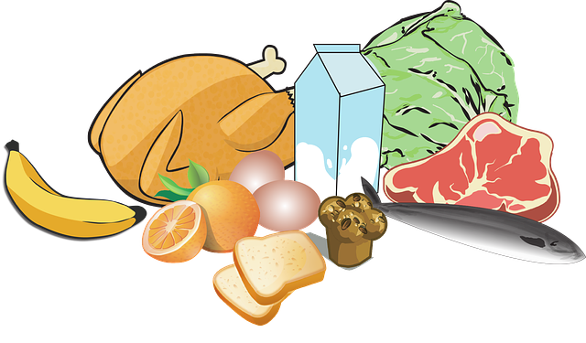
We should not be surprised therefore, that it is challenging to change our dietary habits. But change we must. For an average UK resident 28% of our 11 tonnes of carbon emissions come from our food. In a climate emergency this is not sustainable.
If we are to keep global average temperatures below 1.5 degrees of heating, we need to take large-scale action in the next 10 year. What we put on our plates is part of this.
To help us take action we are running a 10 Pledges programme across the diocese. Choosing to have two locally sourced meals a week if the second of the 10 Pledges. This means “in season” food produced in the UK or more locally. In the autumn, that means fruit and veg such as apples and pears, squashes, mushrooms, sweetcorn, kale, beetroot, carrots, parsnips, swedes and potatoes. You could just start simply with porridge for breakfast!
As we went into lockdown in March, we were all given a wakeup call about the complex web of food supply chains we rely on to put groceries on the supermarket shelves. Many people had never really thought about where, or how, their strawberries or beans were actually grown let alone the carbon cost of choosing to have, say, rice instead of potatoes or pasta.
Becoming more aware of where our food comes from helps us to be more appreciative of God’s blessing to us through creation, as well as of the farming community who are amazing guardians of the land. It also helps us become more discerning shoppers as we can choose to support farmers who strive to enrich their farm’s biodiversity, reduce carbon emissions and water pollution, through for example farming organically.
Food miles are an important part of the carbon emissions from our food, on average transport makes up 19% of the carbon cost of food. How the food products are grown and processed are however, more significant, with the “on the farm” emission making up 45% and the “in the factory” emission 28%. And while we are right to be concerned about disposing of the packaging correctly, the carbon produced in making food packaging is only a small part, 7%, of its overall carbon emissions on average.
This Harvest as we thank God for His goodness, can you review your diet and pledge to reduce the carbon footprint of your food? www.leeds.anglican.org/environment/lifestyles

Jemima Parker, Diocesan Environment Officer
September 2020

