Quick Action Stations! There’s A COP coming!

What’s all this in the news about COP26? Is it a fair COP? Will I COP it? No it’s not a conference for 26 police people, but rather the 26th UN Conference of Parties, the latest round of international climate change talks to be held in Glasgow from 1st -12th November. But what has that got to do with Christians?
Of course, the Climate Emergency – and the related Ecological Emergency – is of significance to every single person on this planet. If we are not being directly affected by it yet, we will be very soon, unless we are prepared to make very significant changes on both the individual and societal levels. A straightforward concern for our own futures ought to be enough to make us act. But are there any reasons why people of faith, including us as Christians, should be especially involved? I believe there are.
Firstly, there is the central Christian teaching about love of our neighbours. We all know that ‘neighbour’ is a pretty much all-embracing term. All of those people in parts of the world already affected by climate change are our neighbours: rainforest communities whose homes are destroyed as the trees are cut down; Pacific islanders threatened by rising sea levels; the people of Bangladesh whose annual monsoon season can now see as much as a third of the country under water; the Maasai people of Kenya and Tanzania who must migrate further to find grazing for their herds in an increasingly dry land. And then there are our neighbours who have yet to be born, the future generations who will inherit the earth we are shaping. We are called to love them too.
Secondly, there is the ‘other-than-human’ world for us to consider, the rest of God’s creation: all of those other ‘creatures’ – animals, fish, birds, insects, yes, but also plants, the soil and rocks, the very air we breathe. All of this is creation, declared ‘good’ by God in the first Genesis creation story (Genesis 1:31). All of this is the ‘world’ that God loved so much (John 3:16) that Jesus came here to show us the way to eternal life. Christian scripture makes it abundantly clear that God loves and cares for everything that God has made, and it seems to me that we, who are made in the image of God, should also love and care for that whole creation.
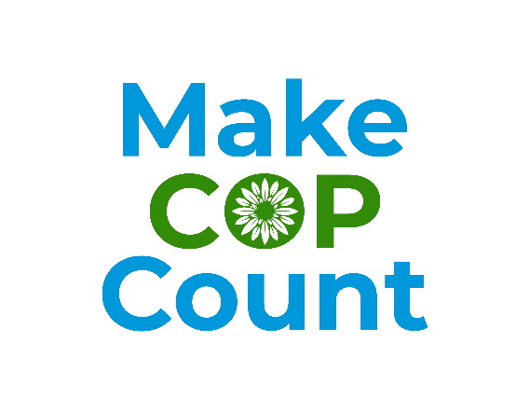
Working to tackle the Climate Emergency is an important way of living out our Christian calling to love our neighbours, and also of reflecting God’s inclusive love by caring for creation as a whole. One way we can show this love is to pledge to take one personal carbon reduction step to show your solidarity. Get ideas and sign up your step with millions from around the wold at Count Us In www.count-us-in.org/en-gb/ . Additionally you may want to support Make COP Count http://makecopcount.org/ calling on our political leaders for fairer global climate solutions.
I suspect – and I hope – that there are some big changes ahead for us all, changes that will help all of creation, both human and other-than-human, to flourish as God intends.
Rev Dr Jan Goodair
Joint Area Environment Champion – Leeds

