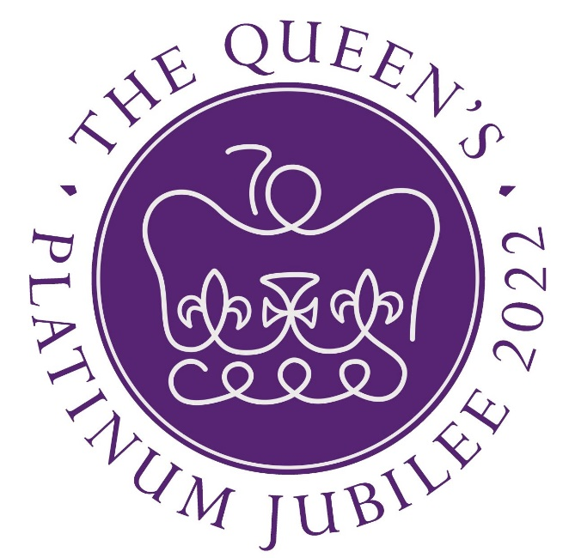
Green and Platinum Jubilee Celebrations?

This year World Environment Day, here in the UK, coincides with the Queen’s Platinum Jubilee celebration weekend.

World Environment Day reminds all of us to protect the natural world around us, our home - planet earth.
Discussions around themes such as air pollution, marine pollution, human overpopulation, climate change and global warming urge us to act from a worldwide perspective and to shift to more sustainable greener life styles. World Environment Day is usually marked on June 5^{th,} but many of our churches will quite understandably be celebrating the Queen’s Platinum Jubilee that day.

The Queen’s Green Canopy (QGC) has been created to mark the occasion by inviting people to ‘Plant a Tree for the Jubilee’ as a UK-wide initiative and brings to our attention Royal involvement with environmental issues. The RSPB (Royal Society for the Protection of Birds) was founded in 1889 and incorporated by Royal Charter. Originally granted by King Edward VII in November 1904, and now held by Queen Elizabeth II, the Royal Charter is the legal instrument giving the RSPB its legal status.

The Duke of Edinburgh also showed a key interest in the environment. After visiting Antarctica and the South Atlantic in 1956/1957, Prince Philip devoted himself to raising public awareness of the relationship of humanity with the environment. He became the first President of World Wildlife Fund from its formation in 1961 until 1982, and International President of WWF (later the World Wide Fund for Nature) from 1981 – 1996, and then President Emeritus until his death last year.

The Duke of Cambridge too has a long-standing passion for the protection of wildlife. For a number of years, he has focussed his work on the urgent global effort required to tackle illegal wildlife trade. He is aware that failing to tackle these issues will allow animals such as elephant and rhino to go extinct, which will be a major blow to our world and to our collective confidence to confront any global challenge.

Together with the Duchess of Cambridge, the Royal couple created “The Earthshot Prize” in 2021, which has led an unprecedented global search for the most inspiring and innovative solutions to the greatest environmental challenges facing our planet.

There is more. So on June 5th when celebrating the Queen’s Platinum Jubilee, let’s also remember all the work with which the Royals are involved with to sustain, protect and continue raising awareness of our relationship with the environment and the ethics of earth-keeping.

Christine Jack, Christ Church, High Harrogate.

