Sun and rain: friends or foes?
My Mum used to line us up with our backs to the summer sun, eyes closed. She told us to turn very slowly until we could feel the full warmth on our faces. ’That is what the love of God feels like,’ she said.
We sing at Harvest, ‘The breezes and the sunshine and soft refreshing rain..’ but, our climate is no longer so benign. This year we have had the hottest July recorded on Earth. You have seen the droughts and fires. You have also seen the intense rainfall resulting in landslide and flood, wreaking mayhem upon millions of people’s lives who are displaced, impoverished, starved or left battling disease. Many are dying as a direct result of this.
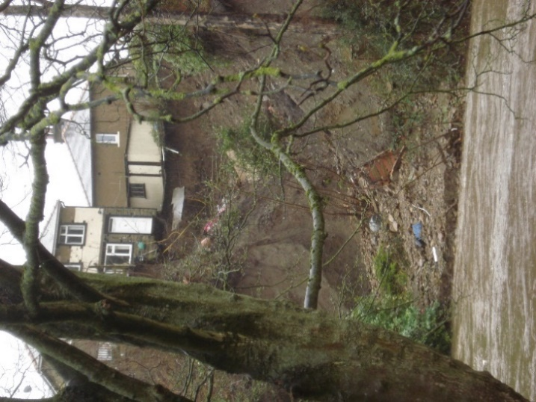
Closer to home, there is now a twenty-foot drop outside the back door of a house in Riddlesden, into the River Aire, where rain from storm Arwen could not find another route in Feb 2022. The fires on Marsden Moor June 2023 are local testimony of how the precious commodity of a stable climate is under threat.
As we pollute our planet, so the blanket around the Earth gets thicker, stopping heat from escaping and changing established weather systems. Every type of weather is now more extreme. Whilst El Nino (a naturally occurring climate warming phenomenon) has been around for centuries, now, when it returns, combining with the warmer sea temperatures results in much hotter weather. La Nina (a cooling phase) has not had her usual cooling effect. The Gulf Stream may be weakening.
So much of our society is structured around using fossil fuel, we are effectively addicted to polluting through every emission from our homes, cars and travel and from our food (methane from cows and nitrous oxide from fertiliser). This addiction is responsible for the climate emergency.
In Richard Rohr’s book, ’Breathing Underwater’, he uses the AA’s Twelve Steps to help Christians tackle addiction in their lives. Step five reads ‘Admitted to God, to ourselves and to other human beings the exact nature of our wrongs.’ Rohr says ‘The revelation from the Cross and the twelve steps is that sin and failure are the setting and opportunity for the transformation and enlightenment of the offender.’ Then in step 8 he suggests we must ‘…become willing to make amends.’ In Mathew 25 Jesus says that whatever we did or ‘did not do for one of the least of these, you did not do it to me.’
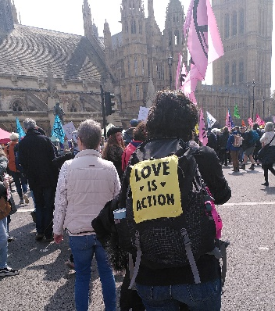
So what can I do? Here are a three ideas to get started.
Firstly, use your political influence. There are some simple policy changes that could make a big difference. Do you remember Nero ‘fiddling while Rome burns’? While there is still no compulsive regulation on installing solar panels on every suitably placed new house, Grant Shapps (until recently Secretary of State for Energy Security and Net Zero), has announced investment of £4.3 million to develop the beaming back of solar power from satellites!
Secondly, don’t buy that air conditioning unit yet! Reduce heat impacts by insulating your home. If you can shade the western and southern aspects of your house with planting. Using external structures such as awnings, shutters, pergolas and porches all reduce the air temperature before the heat hits the drawn curtains and blinds.
Thirdly, consume less water www.watercalculator.org/ and conserve rain all year round. This not only helps in drought, but you can ‘slow the flow’ during heavy rain when river levels are high (find out more here https://slowtheflow.net/you-can-slow-the-flow-general-principles/ ). If you have a garden you could run a hose from a water butt into the gardens during heavy rain, not into the drains. What about having an extra butt attached to the downpipe from your shower? Don’t forget the old saying 'if it's yellow let it mellow; if it's brown wash it down', so using less water becomes a year round habit!
Jesus said ‘I have come that they may have life in its fullness.’ John 10. There is real hope for us all to enjoy this fullness! Halving our carbon emissions in the next six years will halt the temperature rising further if we take collaborative action now! It’s up to us.

Diana Chambers
St Mary’s Church, Riddlesden

