Trees: Who Gives a Crap?
By Diana Chambers
On either side of the river is the tree of life with its twelve kinds of fruit, producing fruit each month; and the leaves of the trees are for the healing of the nations. Nothing accursed will be found there anymore. Revelation 22:2

Trees are used from the very beginning of the Bible until the last page, to demonstrate restoration, protection, God’s love, hope, wisdom and through Him, life.
In the struggle to rein in our greenhouse gas emissions, planting trees is essential; they absorb carbon dioxide and give out oxygen (life).
Many of you will have taken the opportunity to 'off-set' the carbon from holiday flights, now offered by many airlines. These usually involve tree planting schemes. Have you considered the madness of then cutting down mature trees for our toilet paper? According to Climate Stewards (Climatestewards.org), a return flight for two people from Manchester to Lisbon generates one tonne carbon dioxide. One tree takes 100 years to absorb one tonne of carbon dioxide.

The Ethical Consumer Magazine describes our loo roll habit like this, ‘We have come to expect that anything we wipe our bottoms with should feel the equivalent to the kiss of a baby alpaca’!

We do need trees for higher grade paper products and paper can only be recycled seven times, it is true; but in the UK, we have become champions of recycling pre- and post-consumer paper, even exporting it to the EU and China. Now we need to become champions of using recycled products.

What should we look for? Under the FSC (Forestry Stewardship Certified) logo check for the ‘100% recycled’ not the word MIX (containing virgin tree pulp), found on most supermarket rolls. How about sharing a box of 48 rolls from Whogivesacrap.org? Competitively priced, each roll is individually wrapped in pretty paper that can be used later to wrap a present.

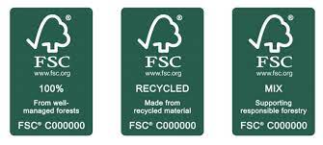
However, the B Corp company nakedsprout.uk, have an even lower carbon footprint in the processing of bamboo (an alternative to wood). At their Spanish plant they harness renewable energy, use local water sources responsibly and deliver with sustainable transport systems.

Another simple way to plant trees is to change the search engine on your laptop, phone or PC to Ecosia who plant trees to offset your internet use. Each time you do an internet search it generates a few grams of carbon from the energy needed to run the server. It’s not much but our internet surfing adds up day by day and over each year.

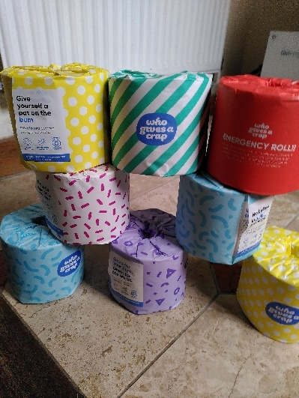
The Forestry Commission reports that the greatest threat to woodland in the UK at present, is the over grazing of deer who nibble away new tree shoots. Scottish Environment LINK reported explains “As well as damaging emerging woodlands and peatlands, Scotland’s red deer alone produce 5,500 tonnes of methane each year – the equivalent of 137,500 tonnes of CO2. A 20 percent reduction in numbers would save the carbon equivalent of around 15 million car miles on Scotland’s roads each year”.

For those of you who have cut back the meat in your diet, but occasionally long for some on special occasions, seek out wild venison providers such as those found at wildhartvenison.co.uk. Wild herds on Dartmoor are managed humanely, so that they and the natural world they inhabit, continue to thrive in a better balance. Unchecked by top predators deer have proliferated, particularly in the south and northern parts of the UK. Buying farmed venison, however, contributes additionally to the methane-producing problem.

It may be the end of Creationtide season in the church calendar, but our dedication to restoring our planet is on-going. Let’s keep protecting those trees!

For you shall go out with joy and be led back in peace…and all the trees of the field shall clap their hands. Instead of the thorn shall come up the cypress; instead of the briar shall come up the myrtle and it shall be to the Lord for a memorial for an everlasting sign that shall not be cut off.
Isaiah 55:12-13

November 2023

