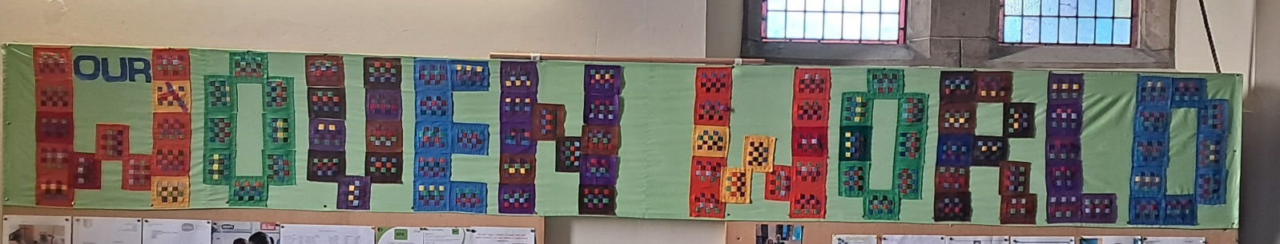

Our Woven World: What have Creationtide and Fairtrade Fortnight meant for us?

Diana Chambers, Eco Mission Enabler

Officially, the Church of England’s Season of Creation runs from September 1st to October 4th and Fairtrade Fortnight was 9th September to 22nd. But of course, we need to consider the connections we have to everything and everyone on this planet Earth, every single day.

St Mary’s Church, Riddlesden, have created a banner from squares woven by many different groups and individuals in our village. It says: ‘Our Woven World’, which will advertise that they are an Eco Church, but what does it actually reflect in our lives?

Firstly, Bradford Cathedral’s vision for the next five years has the theme of being woven together, reflecting not just the City’s textile history, but how Jesus’ love for the world is shown through ourconnections with each other and the world around us. They plan to be carbon zero by 2030.

Secondly, through Fairtrade Fortnight the Coop supermarket celebrated 30 years of working for trade justice, highlighting our responsibilities and connections beyond borders to people we don’t know*,* who produce our food, clothes and other goods across the world.

Thirdly, as the woven squares on the banner illustrate, every part of our existence is connected with the natural world: through the air we breathe – purple; the water we drink – blue; the land – brown; all growing life – green; and lastly red, yellow and orange representing fire, that element which helped in our civilisation and, as we have seen, may yet destroy us if we continue to mess with the delicate balance of our atmosphere.

**The Earth O Lord, is full of thy steadfast Love; teach me your laws!** Ps. 119.64.

So how can we hope and act with Creation? As we saw at the time of riots across Britain this summer, the amazing work between faith groups and communities in Bradford and Keighley living side by side, will have contributed to there being no trouble here.

When we pay the proper price for our goods and aid those most affected by climate change through no fault of their own, their communities are more likely to survive and flourish without the need to migrate somewhere else. When ploughing is stopped and the exhausted soil is planted directly, look how it thrives! When areas of the oceans are left alone, we have seen how they regenerate with abundance of life.

The truth is, when we reach out in loving awareness to each other, to those far away and to the natural world, we are often repaid ten-fold, as well as knowing it is the right thing to do.

God’s steadfast love is then so clearly shown in His Creation, as this poem says:

**The Weaver**

My Life is but a weaving between my Lord and me;

I cannot choose the colours He worketh steadily.

Oft times He weaveth sorrow and I, in foolish pride,

Forget He sees the upper, and I the underside.

Not til the loom is silent and the shuttles cease to fly,

Shall God unroll the canvas and explain the reason why.

The dark threads are as needful in the Weaver's skilful hand,

As the threads of gold and silver in the pattern He has planned.

*Attributed to many people*.