
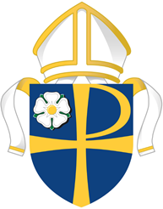

A.D. 2026

VISITATION

of the Archdeacons

Diocese of Leeds

Citation

TO all Licensed Clergy and Churchwardens for 2025 and for 2026 of each and every parish in the Diocese of Leeds.

The Archdeacons of the Diocese of Leeds are holding their Visitations and

YOU ARE CITED to appear before the Archdeacons on either:

BRADFORD ARCHDEACONRY
Wednesday 17th June 7.00pm for 7.30pm – held at All Saints, Ilkley

Tuesday 23rd June 7.00pm for 7.30pm – held at Bowling St John, Bradford

HALIFAX ARCHDEACONRY

Thursday 11th June 7.00pm for 7.30pm - held at Halifax Minster

Sunday 14th June 2.30pm for 3.00pm - held at Huddersfield Parish Church

Tuesday 16th June 7.00pm for 7.30pm - held at Dewsbury Minster

LEEDS ARCHDEACONRY
Thursday 4th June 7.00pm – East Leeds Deanery – held at St Matthew’s, Chapel Allerton
Thursday 11th June 2.00pm – South Leeds Deanery – held at St Thomas’, Stanningley
Tuesday 16th June 7.00pm – North West Leeds Deanery – held at St Giles, Bramhope

PONTEFRACT ARCHDEACONRY

Wednesday 3rd June 7.00pm – held at St Giles, Pontefract

Tuesday 14th July 7.00pm – held at St John the Baptist, Royston, Barnsley

RICHMOND AND CRAVEN ARCHDEACONRY

Thursday 2nd July 7.30pm – Ripon Deanery – held at Ripon Cathedral

At the Visitations the Archdeacon will deliver a charge to the clergy and churchwardens.

Churchwardens for the coming year will make their declarations at the Visitation Court prior to being admitted into office.

Those prevented from attending by illness or other cause should notify the Registrar in writing.

Whilst Readers, members of Parochial Church Councils and parish and diocesan officers are not cited to attend, they are warmly invited by the Archdeacons to do so.

Dated this Twenty First day of January 2026

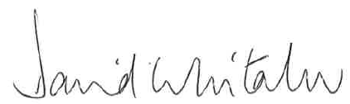
…………………………………………..
David Whitaker
Registrar and Bishops Legal Secretary

