

**A Vacancy in the**

**Benefice:**

**Writing a**

**Successful**

**Parish Brochure**

# **Why do you need a parish brochure?**

We all know the reality….. at present there are not enough clergy for the parishes in the country, so parishes cannot assume there is someone just waiting to come to them. We have to convince the right person why they should consider coming to us. A parish brochure is the best way to achieve this.

### The brochure is a key document which has two aims:

* It is the first picture a possible new priest will get of the parish.
* It is the PCC’s guidance note for the parish representatives considering a candidate.

Writing a good, honest, attractive brochure should make it easier to get the right person for your parish, so spend the time to get it right; it is worth it.

The brochure should be drafted by a small group, but the final version needs to be agreed by the whole PCC.

The brochure goes to the Bishops and Archdeacons to help them look for the right person for your parish, and it will be read by anyone interested in applying for the role.

# **Helping you with your brochure**

The diocese wants to help you write a successful brochure and these notes, giving you some hints and tips, are part of that support. It explains what should be included and gives you a structure to help you get started.

An example of a brochure has been sent alongside this guide. Examples of other brochures from parishes in your area can be obtained from the Archdeacon’s secretary.

# **Thinking about the content**

In order to produce a balanced brochure you should spend some time thinking about the parish as a whole. It may be helpful to do a simple exercise thinking about the strengths, weaknesses, opportunities and threats. This will give a good idea about your present context.

*Strengths*

* What are you good at?
* What works well?
* What would you not like to change?
* What makes you proud to be in your parish?

*Weaknesses*

* What doesn’t work?
* What would you like someone to help you do better? (It might be a service that isn’t working as well as it might or a group that has seen falling numbers over the years).

*Opportunities*

* Where are the possibilities for mission and growth that a new person might be able to help with?
* What don’t you do that you would like to?

*Threats*

* What could bring the whole parish crashing down?
* Is it a problem with a building?
* Is it a project that is going wrong?
* Are there any serious issues to tackle?

### Have this grid with you as you think through writing your brochure.

**Ten Top Tips for Writing a Successful Brochure**

1. **Be upbeat and positive**

You are trying to attract someone so you want to tell them why your parish is a good place to be. There are always good things happening, good stories to tell no matter how tough it may feel.

2. **Be honest**

There is no point hiding the truth. If you have been through a tough time or there are major problems then say so. You should, however, also show that you are willing to work with the right person to overcome any problems and work to the future.

3. **Keep it simple**

If it is difficult to read people won’t bother. Write short sentences and paragraphs. Use headings and lists to break the text up. Use plain English not jargon. You will need facts and figures but don’t make them too detailed or complicated.

4. **Make it look nice**

Design matters. It does not have to be designed by a professional but making a page look attractive will help the reader. Use photographs to illustrate what you are saying. They will help the reader visualize your parish, but don’t just photograph buildings. The brochure will come to life with photos of the different people connected to your Church.

5. **Make it web and email friendly**

The Diocese is trying to put much more information on its website and be able email it to interested people, so an electronic version of the brochure will be needed. Don’t panic though, your Archdeacon’s secretary will be able to help with this.

6. **Keep it human**

Candidates will want to know about the kind of people they are likely to be working with, so include quotes from different people in the congregation about the different aspects of your Church. You can use their quotes (and pictures) to add colour and flavour to the text.

7. **Don’t try and put everything in**

Candidates are often put off by having too much information. You should inspire them to want to know more. You can’t fit it all in and leaving some gaps will help you work out who is interested enough to ask more.

8. **Remember who you are writing for**

The best brochure assumes that you are writing for someone who knows nothing about you. You should try and introduce yourself and help them understand who you are as a parish and what you are like.

9. **Be inspiring and challenging**

Brochures can often contain lots of information but no sense of what is important. It can be tempting to present a picture either of a perfect Church or one that is beset with problems. You need to show all sides, point out where the challenges are, what may need changing and where a difference can be made. The brochure needs to show what the parish will be like when they arrive and show the potential for it to be a changed place (for the better!) before they leave.

10. **Check it with others**

A fresh pair of eyes will see what you have missed and be able to tell you what they don’t understand about what you have written. There is plenty of support you can get to help make your brochure a real success.

***Remember****…….. people will want to read something, straightforward, upbeat and honest. Enough to make them think “that’s sounds like the place I want to be”, but not too over the top that they wonder “that can’t be true”.*

# **Section by Section: An Attractive Brochure**

We recommend that your brochure should have 5 sections, in the following order. You can adapt this to a style you may prefer but we find that this layout makes it most helpful for the reader.

*(Although the brochure should be presented in this order, it may not be helpful to actually write it in this order!).*

**Section 1: Summary of the brochure**

**Section 2: The priest you want**

**Section 3: About the parish**

**Section 4: About the Church**

* + - * *The Church and its people*
      * *The Church and the community*
      * *The Church and its buildings*
      * *The Church and its finances*

**Section 5: About the wider context**

You need to get the balance between writing too little and too much. We recommend about 8 sides of A4.

This chapter explains the purpose of each section, with ideas for its content.

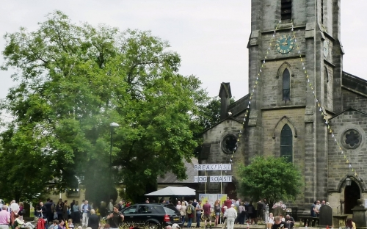

## ***Section 1: Summary of the Brochure***

This section should grab attention. Get it right and the person for your parish will want to read the whole brochure and pursue things further. Get it wrong and they will be put off or, worse still, you will attract the attention of someone not right for your parish.

A summary is just that. A short (no more than 1 side of A4) digest of your brochure. It should highlight the main points and the areas that make you unique. It should make someone say “I could see myself there”.

If you have a parish vision or mission statement you can include it here.

If your parish has a website put its address in this section. For many people the first thing they will do is try to find you on the internet so make sure your site is up to date and reflects the life of your parish.

This is also be a good place to report on whether your PCC passed a resolution under the Bishops and Priest (Consecration and Ordination of Women) Measure of 2014.

**Note:**

**While this is the first page of the brochure, it is best to write it last. You can then make sure it reflects what the parish is like.**

## ***Section 2: The Priest You Want***

In this section you should define the qualities and values that you want from your new priest. It is tempting to be unrealistic and ask for the impossible.

You need to think about who will truly help your Church’s mission and ministry move forward.

You need to think what is essential for the new priest to have and what would be desirable. What are the qualities that you need to help the Church grow and develop? If you have a good clear picture of the life and ministry of your Church it should be equally clear what kind of person you want.

The best approach is to make a list of all essential and desirable characteristics. Ask yourselves candidly and honestly what are the absolute bottom line, non negotiable, definitely must have qualities a candidate must have? The ones that if you don’t see them you probably won’t see an effective ministry from them. These will be the essentials.

After that, you need a shorter list of qualities you would really like to see. These will be the desirables.

Remember you can’t have everything, so try not to list more than 10 – 12 characteristics for each. Focus on what is most important to you.

Do however mention that you expect them to take proper holidays and days off and that you will support them in their training (CMD), and reading and personal development – assuming all this is true! It shows an understanding and concern for their health, well-being and development.

*“Parishes can be unrealistic when it comes to stating the type of vicar they want saying in effect ‘we want an outstanding preacher and service leader, who has a real concern for young people, old people, single people and the family, has a real heart for ministering to people at the margins of our community, who is a visionary leader but is also extremely collaborative, gets on marvellously with every age group, listens beautifully, loves every form of service going and will visit us all at least once a week unless we are in hospital in which case s/he will visit us more regularly. Oh, and s/he must be brilliant at getting in money, too’.*

*This leads to the standard joke about the Archangel Gabriel not being available”.*

***Section 3: About the Parish***

This section gives an overview about the parish it is helpful to include details about:

* Where the parish is – village/town, deanery, Episcopal Area
* The names of any churches in the parish
* How many people live there
* How you would describe it – urban, suburban, rural, new town, small town, village, high income, low income etc.
* What kind of people – age/social/ethnic mix, is the population mobile or static, is it rising or falling?
* Any particular features – particular problems, landmarks, famous people (now or in the past) – anything to give a bit of a flavour of what the place is like.

You could include a list of the best 3 things about the parish. You may want to include a map to show the area.

You need to attract someone to come and live in your parish, and so the brochure needs to show what makes it a good place to live.

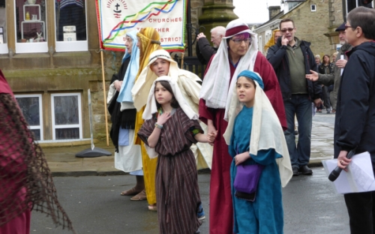

## ***Section 4: About the Church***

This section aims to give as full a picture as possible about your church.

## **The Church and its people**

This aims to give a flavour of church life. Using a mixture of facts, figures and narrative you can describe what is going on at the present time as well as future challenges. You need to balance the negatives with the positives. It is easy to see all the things you want to be fixed and things you have always wanted to be done, but you also need to think of all the activities you are good at and are proud of.

### In this section include:

* Details of people in the church – wardens, PCC Secretary, other clergy, Readers, administrators
* A list of services and numbers and kinds of people who attend - age groups, social/ economic/ethnic mix, number from outside the parish
* A brief description of the variety of worship patterns
* The overall churchmanship of the church
* The involvement (or not) of children and young people
* The different activities that your church family is involved with – bible study groups, prayer meetings, youth clubs, bell ringing, choirs, music groups
* The number of people on the electoral roll and the number who live out of parish

Remember to talk about people. Look at your strengths and weaknesses. Think about where you are growing. What are your hopes and aspirations? You are trying to encourage someone to join you, so give them good reasons to do so.

Also, as the Church is about people, include some quotes and pictures about people doing the activities you describe.

## **The Church and the community**

Here we aim to look at the part the Church plays in the life of the community.

You may want to list:

* The weddings, baptisms and funerals (including at the crematorium) that you do, plus the support you offer (if any) to people as part of that
* The kinds of groups and activities taking place in church buildings
* The different services you offer to the community from home communion to befriending services, from film clubs to toddler groups, from lunch clubs to quiz nights
* Any links with local schools
* Any special relationships with local organisations and institutions (eg hospitals, residential homes for the elderly, homeless organisations, prisons)
* Any special links with the local authority or particular civic responsibilities on the part of the priest
* The different ways church members are involved in the community
* How you work with and relate to other churches and denominations
* Your support for home and overseas mission and charities

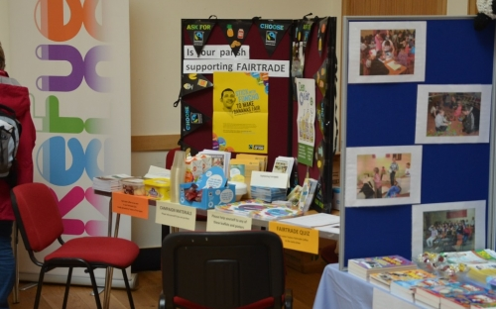

There may well be overlap in these two sections but don’t worry. Don’t spend too much time debating the subtle differences between the two.

Remember things change. Some activities may have folded during the interregnum and they might not get back up and running. That is fine. Be honest about it but don’t make the potential priest think s/he has to pick up the things left over by the previous priest.

There is a potential risk that this section could end up long and unrealistic, mixing actual activity with what you may wish to do. Be honest. The priest needs to know what s/he will be dealing with, not some details about the fantasy church of your dreams.

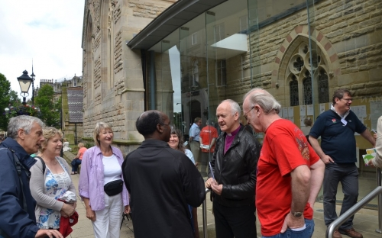

## **The Church and its buildings**

Buildings can be blessings or curses. Some are in an excellent state of repair and right for the use they are being put. Most are not.

The clergy are not called to be building managers but they see the importance of having the right buildings for worship, mission and ministry. You need to give a realistic appraisal of what you have and any plans for change.

Try not to describe every last detail of your beautiful or not so beautiful church.

You should give an honest idea about:

* What kind of condition are the buildings in?

Briefly describe any major works completed in the last few years.

* When was the last QI? Were there any major issues identified? Are there any plans to address these?
* Are there people around who are prepared to take at least some of the responsibility for looking after the buildings?
* How often the buildings are used, and by whom?
* The scope for new mission and ministry activity within the buildings.

Where possible, show the positives and the possibilities, but beware of painting a picture of a church building as a museum piece. There is a difference between having a beautiful church building that you want to keep looking great and the building becoming the thing you worship. Avoid the latter at all costs!

The vicarage is another key attraction as it will be their home as well as their base for ministry. What is the house like and is it in a good condition? Are there any plans to improve the vicarage, or even sell it and replace it?

## **The Church and its finances**

## As with buildings, the church’s finances can cause worry for the incoming priest and the parish. It is important that s/he understands your financial position.

## Are the parish finances healthy, are you just about breaking even, have you or are you hitting real problems?

## Have you managed to meet your share in the last few years? Indicators like the number of regular givers, average weekly giving, how much Gift Aid is recovered and the most recent stewardship campaign can be helpful.

## Mention if you have any other income streams for the church (eg legacies, hall rentals, fundraising committee).

## You should always enclose a set of your most recent accounts with your Parish Brochure.

## It’s also worth saying that you pay reasonable clergy expenses in full (if you do!).

## St Thomas Greetland gets ready for le Tour

## ***Section 5: About the Wider Context***

It is important that the potential priest understands the wider context s/he will be coming into. The Area Bishop will be able to provide you with an overview of how your parish fits into the wider Episcopal Area plan.

A potential priest needs to understand what kind of support s/he can expect, whether in a parish context or through the group/team the parish is in.

### You need to try to describe:

* + Any informal (clustering) relationships with other churches and whether, practically, this means anything
  + Your churches involvement in local ‘Churches Together’
  + Whether you have a formally commissioned Shared Ministry Team or other leadership team
  + Any resolutions around the ministry of women priests
  + Any pastoral reorganisation currently taking place or in the pipeline

Most importantly, if you have agreed some priorities for mission, whether as part of your parish mission plan or another document, then explain them and the steps you are taking to implement them

# **Designing and producing your brochure: making it look good and read well**

You don’t have to be a design expert or graphics whizz to make your document look good. Here a few tips:-

***Keep it simple***

The aim is to make people want to read the content, not to bamboozle them with lots of different colours, fonts and styles. A simple 1 or 2 column page layout looks best – but stick to the same one throughout.

***Don’t use block capital or underlines.***

Research has shown that these confuse many readers.

***If your Church has a logo - use it.***

Also, if you have a colour scheme use it here.

***Think about the points you may want to highlight.***

Sometimes it is good to highlight a quote or a paragraph. This draws attention to the important point you are making. You could do this by increasing the font size or changing the text colour.

***Pick a clear font.***

You don’t want too many fonts and they need to be readable. At most, have one font for all your headings and another for the main text. Good fonts are Calibri or Verdana. Choose a good text size. Usually it’s best to be around 12pt in size. Do not use anything smaller than 12 as this is not helpful for some people.

***Limit the colours.***

You don’t need to use any other than black for the text. If you do choose a colour then stick to one for the headings.

***Write simply.***

Use plain language. Short sentences and paragraphs are good. As are lists.

***Think about images.***

They are not just there to make the document look pretty. They help tell the story. It is best to have ones that are relevant to your church and show your people and buildings. Remember to get proper permissions if taking pictures of children and young people. As a rule, it is better to use one larger, strong picture then a number of smaller ones. It may also be helpful to caption some pictures.

***Make it web friendly.***

The best format for making your profile web friendly is as an Adobe Acrobat pdf file. The file should not be too large, ie no more than about 3mb in size.

***Don’t be afraid of white space.***

Don’t go over the top and waste space (and paper); conversely, it is not good to cram everything in.

***Proof check the brochure.***

Having put so much work into the brochure, it would be horrible to have someone point out typing errors or spelling mistakes! Give it to someone who has not been writing it - you won’t see the errors yourself. That person could also tell you how well it reads.

# **A Checklist to Help You**

Once you’ve written your brochure, run through the following checklist.

If the answer to any of the questions is ‘X’ then try to make 1 or 2 changes to correct it.

Is the brochure positive and upbeat?

Does it paint a good, rounded picture of the church and the parish?

Have you included quotes and pictures to give it a nice human feel?

Is the brochure realistic?

Have you made the job of priest sound challenging and rewarding?

Have you described yourselves as positive about change?

Have you been realistic about the church buildings and the vicarage?

Have you been realistic about the skills and qualities you expect from your next priest?

Have you been clear about the challenges s/he can expect to face in your parish?

Have you been honest about the kind of support s/he can expect?

### And finally …..

Having read the brochure, are you excited about the future of your Church?

____________________________________

* Thanks is given to the Diocese of Liverpool for allowing us the use of their text.