Clear Print Guidelines

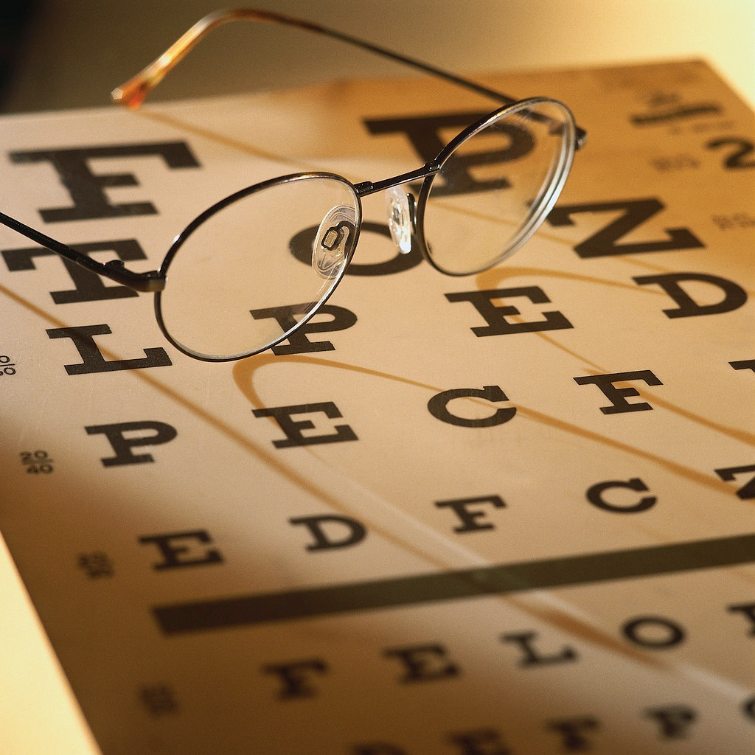
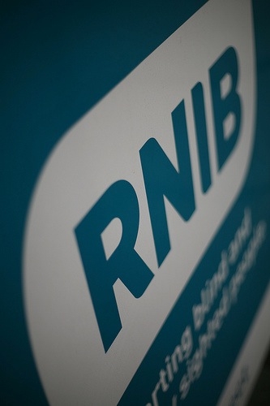
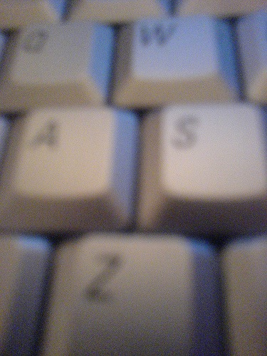

Font Size
The font size (point size) is key in making the printed word easy to read.
We recommend a point size of at least 14 whenever possible, (this document is 16pt).
Quite simply, the larger the font the more people you will reach.
Many people argue that increased font size makes a document bigger and therefore less cost effective. However, we would argue a document that is difficult to read is more likely to be discarded without ever being read in the first place.
How cost effective is this?
We think of it this way; the larger the font, the more people will read it. Simple really, it is easier to read a 12pt document than 10pt and even more people again will read 13 or 14pt text.
The more effort we make toward accessibility, the less effort the reader has to make, and this equals more readers of our documents.
Smaller print equals a smaller audience, larger print equals a larger audience.

Font Style
Highly stylistic fonts, (such as ornamental, decorative, handwriting styles) cause problems for many types of visual impairment and are best avoided.
When we get too ‘arty’ with our typefaces we can’t expect everyone to read it.
We know that there will be times when you may still consider using a more arty font. All we ask is that you consider your target audience and that you realise there may be a trade off here. For the sake of an arty font you may lose some of your readers.

Type Weight
Visually impaired people often prefer bold or semi bold weights. We recommend avoiding light type weights at all times and especially if you cannot increase the point size to compensate.

Contrast
We should always work to achieve a distinct contrast between the background and the text, as this makes text far easier to read.
The size and weight of type also affects the contrast considerably and should be given much consideration. For example a thin version of a font style may work well in a heading at 18 or 20pt, but we will need a roman or heavy version of the font for the main body text.
Black text on a white background always gives the best contrast. If another colour scheme is to be used try to find one with a distinctly marked contrast.

Typographical Styles
Whenever possible we should be avoiding underlined or italicised text and BLOCKS OF CAPITAL LETTERS as these are harder to read.
Titles and short phrases in block capitals can be OK, but we should avoid using them in longer phrases.
Underlining or italicising text for emphasis needs to be avoided and we should explore other methods of emphasis such as colour change etc.

Leading
The space between two lines of text is known as leading. It is important. The larger the leading the easier it will be for everyone to read. However, as a general rule this space should be 1.2 to 2 times the space between words on a line. Increasing the leading on a document can be beneficial in many ways. The copy generally looks far more welcoming not only because it looks easy to read, but also because the reader will believe that the text will take far less time to read than if it was tightly packed. A larger leading space gives the impression that there is less text than there actually is.

Numbering
If we are printing a document with numbers, we should look at the numbers in the font we have selected and use a clear font. Numbers that are curly, such as 3 5 and 8 can be difficult. When printing columns of numbers it is best if we can try to increase the kerning around the numbers, (space between characters) wherever possible. 1211132 is not as good as 1 2 1 1 1 3 2. If it is not essential that the numbers be in columns, then we would recommend avoiding their use altogether. Wherever possible, it is better to write numbers out as words: ‘three’ rather than ‘3’.

Spacing and Alignment
It is best if we can maintain the same amount of space between each word. We should not cram or elongate lines of text. Aligning text to the left margin makes it easier to find the start of the following line. It also keeps the spaces between the words equal. We should avoid using Justified text (where the right hand edge is also made straight by altering the spacing on each line); it may look tidy at a glance but it generates uneven spaces between the words making it a lot more difficult to read. Justified text can cause disorientation for many sight problems, causing the reader to lose their place on the page and leading to confusion.

Clear Space (‘Negative’ Space)
When creating a document it is good to think about the use of clear spaces.
Clear space allows people with poor vision the room to orientate themselves on the page.
Space left around objects such as photos and diagrams,

Space between paragraphs

Space around charts etc.

Space away from the edge of the page.

Length
Line length is important.
The eye becomes tired towards the end of a line and we begin to lose focus.
We need the white space at the end of lines.
Lines that are too long begin to eat in to this space and cause us to lose our place on the page. This can be disorientating for many visual impairments.
We should also bear this in mind when considering both the length of sentences and paragraphs.
Many visually-impaired people read books using a CCTV reader - these require the page to have a wide margin, particularly in the “gutter” where the binding is.

Columns
Columns of text should have clear and distinct separation. Unfortunately most programs have a 5mm default margin between columns when it should be at least 7mm. Clear and distinct separation is very important.

Reversed Out Type
When we use reversed out type we should always ensure that we achieve a strong and bold colour contrast with the background. We should avoid using colour tints and try to use strong solid colours on any background that will carry text. To do otherwise will cause parts of the text to ‘white out’ and render it unreadable. Where we use colour fades, we should place text at the darkest end of that fade, however, we must remember that fades are always going to be difficult for visually impaired people and we should try to avoid them where possible.
Like this!

Setting Text
We should always avoid wrapping text around objects such as photos etc., especially irregular shaped objects, as this forces text to align in different places which can become difficult to read. (If you absolutely must use a text wrap place the image to the right of the text so at least it will not disrupt the starting point of each line.)
Laying text over images or textured backgrounds also makes it difficult to read. When laying text over a coloured background remember to maintain a good colour contrast - like the cover of this guide.

Horizontal Text
Text set vertically, as is often done with headings etc., is difficult for partially sighted people to read.
Try to set text horizontally as this is the easiest way for people with poor vision to follow.

Photography
We should try not to overuse photography and ensure the images we do choose are clear and with good contrast.
The use of crisp clear framing which gives a definite edge always helps and we should try to avoid drop shadows or other edge effects. Generally we should not lay text over photography as it just makes the text very difficult to read. If we must, then consider what we have said on reversed out text and contrasts. When we place a caption, we should make sure it is readable, (large enough) and we should not use italics. Try a different colour to differentiate the caption instead. The general rule about photography is ‘less is more’. It can take some people a lot of effort to view a picture so let’s make our pictures count.
We must give a written description of the contents of the photo. Failure to do so will exclude some people from sharing such an experience. This is discriminatory and needs to be given careful thought.

Word Use
We should consider that some words are more difficult to read. Double letters can often cause problems; eg. double l’s in words such as ‘collect’ can be problematic. We know that there are times when this is unavoidable, but think about it - there will often be another word you could use which is easier to read.

Forms
People with poor sight often have larger than average handwriting, so when laying out forms make any text boxes that have to be filled in, bigger. This can also be a great help for those who have restricted movement in their hands.

Cover Design
The cover of any publication is a window to its contents. If the cover appears to be difficult to read then you are in danger of putting the reader off before they have even begun.
Your cover must be well thought out bearing in mind all these guidelines. It is more important to get this right than any other part of your document.
Anyone with a sight problem will glance at a document’s cover and make a judgment about how accessible its contents are likely to be. If the cover appears difficult they will probably never look at the content even though you may have gone to a great deal of trouble to get it right.
This is your first point of contact with someone. Get this wrong and you risk losing them forever.

Prioritise Your Text
It is extremely important that you prioritise your text.
Decide what is key information and what is additional. If space is at a premium, then make sure that your key facts are the things that are the easiest to read and that they take priority over everything else.

Navigational Aids
We should consider carefully the features in our document that recur, such as headings and titles, page numbers, the space between paragraphs and chapters and features such as indents etc.
Try to keep them uniform; and in the case of titles, headers, footers and page numbers, at the same place on each page. This consistency can be a great help to visually impaired people.
We should also consider how we can clearly define useful sections of the document such as content lists.
Finally we should leave space between paragraphs as this gives the eye a break, making reading easier. In some cases we should consider using a key so that visually impaired people know what certain features represent.

Printing
Glossy paper can cause glare and becomes difficult to read and we should try to avoid it. Choose uncoated paper, or if you need the durability of a coating consider a silk or matt finish.
We should also consider the weight of the paper stock and select a heavier weight (100 gsm or higher), to avoid show through, which can also cause problems. If you can see print from the other side then the paper is too light.
We would always recommend the use of environmentally friendly and recycled stock, this is not about accessibility, but it’s just another area of good practice where we can take proper responsibility.

Page Setup
When laying out your page, it is important to remember how it will work for someone with poor vision.
Is the centre margin wide enough?
When the book is open, can you read the words at the ends of lines easily, or do they fall in the shadow of a page fold?
If it can be avoided, try not to use a heavy binding as this will mean the book will not lay flat when open.
Many visually impaired people have to use screen magnification devices which require that the book must lay flat to enter them.

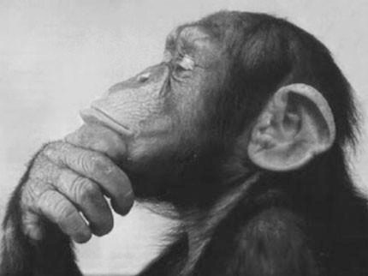
Other Things
To Consider

Should I Use Clear Print?
We need to give careful thought to the purpose of our document. A good general rule to follow is, if our document is for information purposes, then it needs to stick more closely to these guidelines.
Documents such as timetables, menus, financial reports all need to be in clear print.
If the document is there to give essential information and can be considered a core document (ie a document for everyone) then these guidelines most definitely apply.
There are other documents such as adverts etc. where it is more acceptable to make some type of value judgment about your target audience and maybe clear print is not the most important consideration.
However, we would say that not following these guidelines always means running a degree of risk that you are missing some of your target audience or worse still, causing unnecessary offence to someone.
The general rule should be to use Clear Print unless there are very good reasons not to do so.

Enlarging
It is very easy to enlarge printed materials through use of a photocopier. However, this often results in grainy images and oversized paper. This solution is considered poor practice and it fails to genuinely satisfy the need for a large print version of a document. We simply must not do it!
If we have been asked to provide large print then that is what we must do. We need to return to the original document and increase the font size where necessary. We should also change the font style and layout of the document to suit. A blown up, or enlarged image of the original, is often a poor imitation of original quality and not good to read; yet it happens all too often.

Laminating
Increasingly, signs and posters are being laminated. The most common type of lamination pouch gives a high-gloss finish. This causes glare and makes reading difficult for many visually impaired people. We would rather lamination was not used at all, however if you feel you must laminate something, we would recommend the use of a matt lamination pouch.

Hand Written Documents
Where possible we should avoid sending out hand written documents but I know that this is not always possible and there are other exceptions, things such as compliment slips and invitations etc.
Well in these cases it is best to print the words rather than using joined up writing. Try to use bold writing and remember to watch your spacing. Do not use pencil as this can be too faint and remember your colour contrast.
Do not use marker pens that have a thick nib as this can cause lines to meet and letters such as ‘e’ and ‘s’ become difficult to read.

Alternative Formats
These guidelines are about reaching a larger audience with our original documents, rather than routinely producing different ‘large print’ formats for particular people.
There will be times, however, when following these guidelines is not enough to make the document accessible to all and we will need to produce a document in a different format.
This is our legal obligation and we really must not adopt the attitude that we are doing the visually impaired person a favour. We most definitely are not. It is simply their right. Further more, we need to understand that to provide what is required is our only ethical and fair option.
When this is the case, be sure to discuss the needs of the client with the client themselves and never with a third party.
Failure to consult with the client could result in hurt feelings or insult. Even if none were meant, why should we risk it?
Remember only the client knows their specific requirements. Should they require large print, we need to know both font size and font type and where necessary colour scheme. We also need to have a system to provide literature in Braille and Audio formats.
If you do not already have one we strongly recommend you find a supplier now. For us to scratch around for a supplier when we get a request is not good enough as it causes delay and under DDA we have a duty to supply this literature promptly.
Find a supplier now and establish a relationship with them. Make sure they are able to deliver at short notice and where it is Braille, make sure that they have the facility to have that Braille proof read - as incorrect Braille can also cause offence.
We have all had mail where our name was mis-spelt or there were basic mistakes of grammar etc. If such things can offend us, then they are just as offensive to readers of Braille.

Signage
Signage can all too often be a forgotten area of the written media. We would remind you that whatever tips we have given about literature would also apply to signage.
We would also recommend that if you have a building open to the public you have Braille signage in conjunction with Braille indicators.
Buildings such as museums and art galleries should have audio guides - it’s fairly simple to produce one for your church too. We can help!

Websites
Many visually impaired people prefer to access information via their computer, as it is easier for them to adapt the text to their preferred format on-screen. We regard it as no longer acceptable (a) not to have a website, or (b) to have a website that is not up to date with the information contained in other parish publications and newsletters.
Many of the guidelines contained in this guide will also apply to the web.
Although we would prefer that you seek specialist advice regarding the design of your website in relation to accessibility, here are a few things that you most definitely should consider:
- When placing a picture, always remember to use alt-tags, which allow you to give a textual description of the image. Make sure the description accurately describes the people and places in the image. Not to do so is a failure of equality.
- The two recognised standards of accessibility on the web are ‘Bobby’ and ‘WC3’. We would strongly recommend that you run your website through both of these applications and take on board any recommendations they may offer. To do this, follow the links given at the end of this guide.
- Remember our comments about regular features. Make sure that features such as buttons and titles are in the same places on each page and that font styles are consistent. Remember also that the more negative space you leave, the easier your site will be to navigate.
- Always avoid placing text over photography or a heavily patterned background. If you are going to place text over a coloured background, remember what we have said about fades and contrast.
- Try to avoid the use of fancy graphics and any item that may rely on Flash Player. Many visually impaired people access the web by the use of a screen reader. Fancy graphics and Flash Player cause problems for screen readers.
- If you really feel the need to use smaller font sizes, make sure that your site contains the facility to enlarge them.

If you need more specific advice about web accessibility, please contact us and we will be happy to help.
The legislation governing websites is tricky and we would always advise that you consult an expert.

PowerPoint
If used correctly then PowerPoint (or similar) can be a very useful aid to some visually impaired people within the church context.
Always use good colour contrast.
Avoid transitions that use flash effects or rapid movement as these can disorientate visually impaired people.
Remember, the flashier the effect, the more difficult it will be for visually impaired people.
Keep font sizes as big as possible.
Avoid over-fussy fonts.
Try to avoid moving images.
There is a commonly held belief that a blue background with yellow font is the default setting for presentations for visually impaired people. This is simply not so.
Be careful where you place your screen. Avoid areas of direct sunlight or shadow.
Reserve seating nearest the screen for those who don’t see too well.

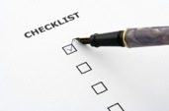
Check List
Here is a quick and easy checklist for anyone wishing to produce a clear print document.
- Is your point size 14 point or more?
If not could it be?
- Is your contrast good?
- Is your font style too fussy?
- Have you avoided using blocks of capitals and italics?
- Is your leading 1.5 to 2 times the space between words?
- Have you used a bold or semi bold typeface?
- When using numbers, have you remembered your spacing?
- Is your alignment correct?
- Have you left sufficient clear space?
- Have you taken regard of the length of lines, sentences and paragraphs?
- Do your columns have a clear degree of separation?
- Is the colour contrast good on our reversed out type?
- Have you checked the setting of your text?
- Is your photography good and clear?
- Does your photography carry a good textual description?
- Have you considered your use of words?
- Have you left enough space for things to be filled in?
- Is your cover well designed?
- Have you prioritised your text?
- Are all your navigational aids in the correct places?
- Are your paper weight and type as good as they can be?
- Have you considered the set up of your page?
- Is it a document that is pleasant and comfortable for you to read. If it is not an enjoyable reading experience for you, then it certainly won’t be a good experience for someone with a visual impairment.

