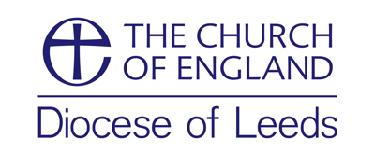


CMD Grant application form

Grants are awarded from your CMD Grant subject to the amount you have available and the agreement of your Clergy Development Officer.

Name:

Parish: -

Phone no:

e-mail address:

Event or course:

Date of course:

Provider: -

How does this event/course address the Development Needs identified in your Ministerial Development Review? What do you hope to gain for the course?

Cost of the course: £

Travel costs (these should not usually exceed the cost of the course): £

Total grant requested (cost of course & travel combined) £

Date

You should consult your Clergy Development Officer in advance to make sure this event/course qualifies for a grant.
For office use –
Receipt/Invoice received ……….……………..
Amount £ ...……………………………………
Date grant authorised …………………………

Then submit this form with receipt or invoice to the Clergy Development Officer for your area:
CMDPGR / CLED
Bradford area: Cat Thatcher
CMDPGR / CLED
Huddersfield area: Sarah Farrimond
Leeds area: Andrew Tawn
Ripon area: Marion Russell
Wakefield area: Peter Townley

