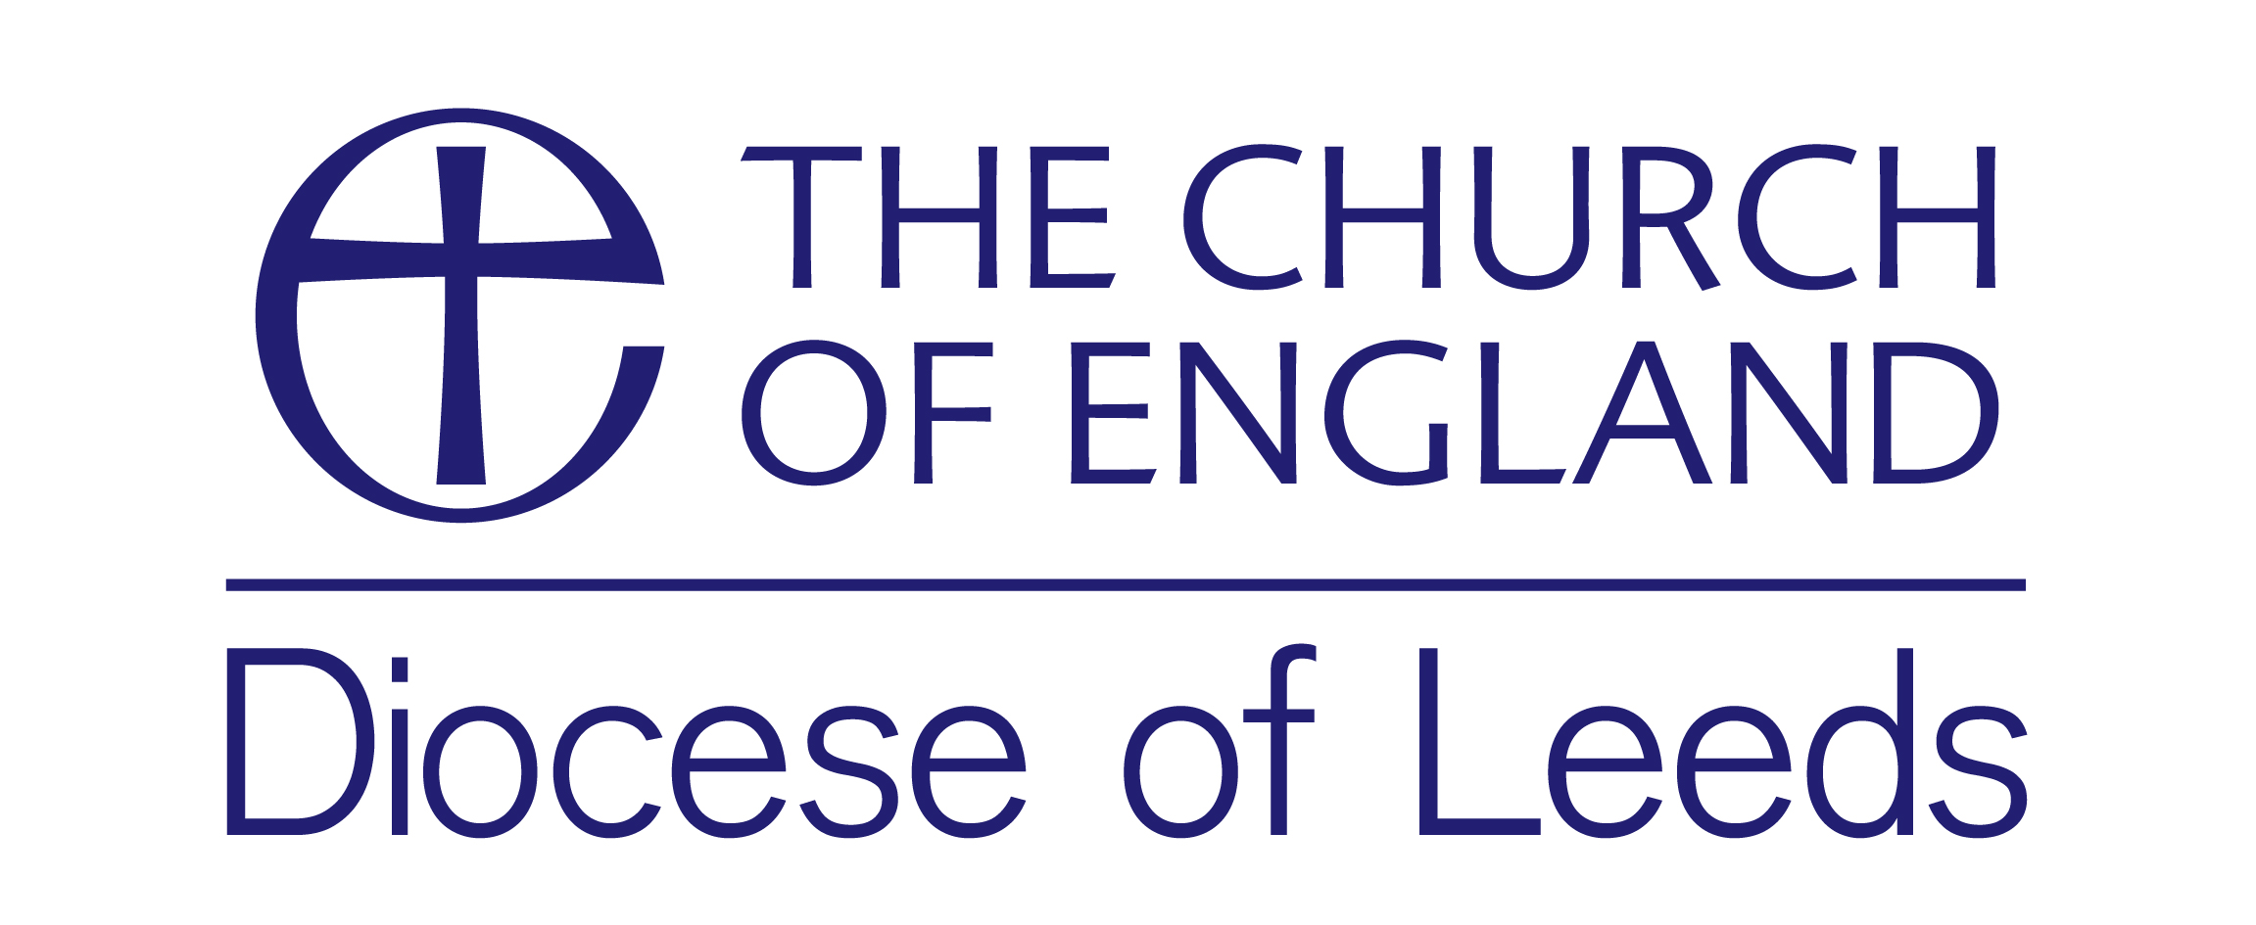

**Please pray for those to be ordained DEACON on Saturday, 29 June 2024**

**For the BRADFORD Area**

**Rebecca Mathen** Benefice of Little Horton

**For the HUDDERSFIELD Area**

**Sarah Long** Benefice of Halifax Holy Trinity &

St Jude

**Mark Naylor** Benefice of Ravensthorpe & Thornhill Lees with Savile Town

**For the LEEDS Area**

**Joanne Medhurst** Benefice of Allerton Bywater, Kippax and Swillington

**For the RIPON Area**

**Esli Lees** Benefice of Harrogate St Mark

**Lorna Heatley** Benefice of Richmond with Hudswell & Downholme and Marske

**Sarah Tapley** Benefice of Starbeck

**Simon Edens** Benefice of Masham and Healey

Benefice of West Tanfield & Well with Snape and North Stainley

**For the WAKEFIELD Area**

**Matthew Brothwood** Benefice of East Wakefield

**Elizabeth Brothwood** Benefice of Sandal Magna

**Joann Byrne** Benefice of Ferrybridge

Benefice of Brotherton

Benefice of Knottingley and Kellington

Benefice of Womersley



**Please pray for those to be ordained PRIEST on Saturday, 22 June 2024**

**For the BRADFORD Area**

**Sharon Bavington** Fountains Church Bradford

**Daniel Furlong** Benefice of Clayton

Benefice of Allerton

Benefice of Fairweather Green

Benefice of Thornton

**Amy Berry** Benefice of Keighley

**Duncan Milwain** Benefice of Bradford Cathedral

**Laity Watters** Benefice of Idle

Benefice of Wrose

Parish of Greengates

**For the HUDDERSFIELD Area**

**Helen Jones** Benefice of Huddersfield Holy Trinity

**Graeme Blackwell** Benefice of Mirfield

**For the LEEDS Area**

**Denise Brogden** Benefice of Drighlington & Gildersome

**Jo Jones** Benefice of Leeds City

**Andrew Earwaker** Benefice of Leeds City

**Elizabeth Reynolds** Benefice of Calverley

**for the RIPON area**

**Karin Shaw** Benefice of High Harrogate St Peter

**Stephen Gibbin** Benefice of High Harrogate St Peter **Emma Halliwell** Benefice of Skipton Christ Church

With Carleton

**Anastasia Tregartha** Benefice of Lower Swale

**For the WAKEFIELD Area**

**Joseph Harrison** Benefice of Monk Bretton

Benefice of Cudworth

**Michael Scholey** Benefice of The Priory