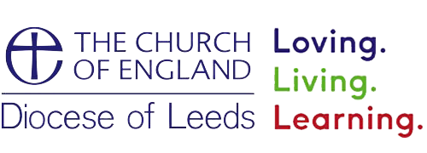

Information regarding Local and National Support Services
(Updated: 13.01.2023)

If you have concerns for your mental state or you feel there is an immediate and serious danger to yourself or another person/child:
- call 999 immediately for an ambulance or the police
- or you can also call 111 when you need medical advice fast but it’s not a 999 emergency

- Disclaimer: this list is indicative only and non-exhaustive. There are many other services that may be appropriate.

Contents

1. National Directories for accessing support Page 3-5
2. Mental Health and Wellbeing Services Pages 6-12
2.1 National Mental Health Support Services Page 7-8
2.2 Local 24 Hour Helplines Page 9-10
- Leeds, Bradford, Ripon, Kirklees and Wakefield
2.4 Additional Local Mental Health Websites Page 11
2.5 Apps and Self-Help Page 11-12
3. Support for Survivors of Sexual Abuse Pages 13-16
3.1 National Helplines and Support Agencies Page 14-15
3.2 Support for Victims/ Survivors of Church Related Abuse Page 15-16
3.3 Additional Resources Page 16
4. Support Agencies and Helplines for Victims/ Survivors of
Domestic Abuse, Stalking and Harassment, Honour Based Violence
and Forced Marriage. Pages 17-21
4.1 Organisations for Women Page 18
4.2 Organisations for Men Page 19
4.3 Organisations for Women and Men Page 19-20

4.4 Organisations for Lesbian, Gay, Bisexual and Transgender People Page 20

4.5 Organisations for people with disabilities Page 21
5. Support for Children and Young People Page 22-25
5.1 Support for children and young people Page 23
5.2 Additional Local Websites for Children and Young People Page 24

1.National Directories for accessing support

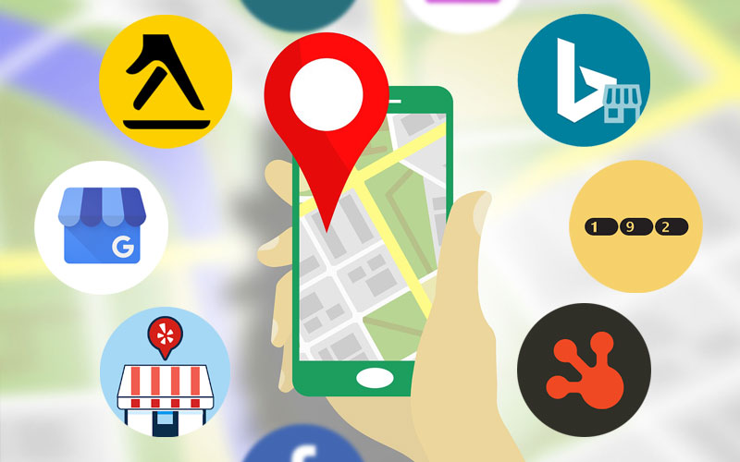

1.National Directories for accessing support

NHS Therapists
NHS therapist therapy is provided through the NHS and should be free of charge. It is possible for victims/ survivors to be referred for therapy through their GP. Alternatively, it is possible to contact some services directly for self-referral.
Improving Access to Psychological Therapies (IAPT) is an NHS programme offering talking therapies for common mental health problems.
IAPT services can be found by searching a postcode here: https://www.nhs.uk/Service-Search/Psychological-therapies-(IAPT)/LocationSearch/10008

The British Association for Counselling and Psychotherapy (BACP)
The BACP is a professional association for members of the counselling profession in the UK. The BACP website holds a directory of members and services that are registered with or accredited by them. Most of these are private and will charge for their services.
It is possible to search their directory via postcode here: https://www.bacp.co.uk/search/Therapists

Counselling Directory
Counselling Directory holds details of individual counsellors and psychotherapists that are personally registered as a member of a relevant professional body, and of counselling/ psychotherapy practices at which at least one of their therapists is registered, or the practice itself is.
The list of the professional bodies they recognise is available at: https://www.counselling-directory.org.uk/accreditation.html
However, they do not monitor changes and therefore it is the responsibility of the person or organisation accessing the service to confirm that the accreditation is still valid.
It is possible to search Counselling Directory by postcode, town or country, here: https://www.counselling-directory.org.uk/adv-search.html

UK Council for Psychotherapy (UKCP)
Psychotherapy offers a non-judgmental, confidential and safe space for you to reflect on any emotional difficulties with a trained therapist. Psychotherapists and psychotherapeutic counsellors are trained to help you express your thoughts and feelings and explore what comes up when you do. The UKCP holds details of registered psychotherapists and psychotherapeutic counsellors. Their register is accredited by the Professional Standards Authority.
It is possible to search their directory by postcode or location here: https://www.psychotherapy.org.uk/find-a-therapist/

Mind – Peer Support Directory
Peer support is when people use their own experiences to help each other. Forms of peer support include: community groups, mentoring, befriending, self-help groups, online communities and support groups. Support is based on sharing experiences and agreeing a reason for meeting. How you choose to meet up or connect with people is very flexible and depends on your personal preferences. Peer support can improve your emotional health, wellbeing and sense of belonging.
A vital part of peer support is mutual respect; peer support aims to help both those giving and receiving support. Everyone's experiences are treated as equally important, so you might find this gives you a different experience to more traditional support options.

For local support groups in your area visit : https://www.mind.org.uk/information-support/peer-support-directory/find-peer-support-where-you-live/?Postcode=leeds&Radius=#localmind-results

Hub of Hope –
A mental health support network and useful resource of local, national, peer, community, charity, private and NHS mental health support and services. Whether your concerned about yourself or a loved one, find out how you can get help from a mental health charity or organisation.
This is available here: https://hubofhope.co.uk/

Helplines Partnership
Helplines Partnership holds a database of helplines that may be suitable for victims/ survivors. The search tool allows for a keyword search and for helplines to be filtered by topic and region.
This is available here: https://helplines.org/helplines/

2. Mental Health and Well-Being Services

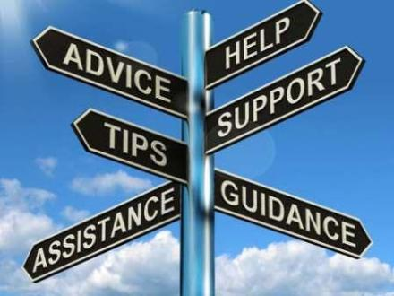

  - National Mental Health Support Services

Samaritans
Samaritans is a registered charity aimed at providing emotional support to anyone in emotional distress, struggling to cope, or at risk of suicide throughout the United Kingdom and Ireland, often through their telephone helpline. Whatever you're going through, a Samaritan will face it with you. Samaritans are open 24 hours a day, 365 days a year.
Helpline: 116 123
Email: jo@samaritans.org
Website : https://www.samaritans.org/

Mind Infoline
Mind provides confidential mental health information services.
With support and understanding, Mind enables people to make informed choices. The Infoline gives information on types of mental health problems, where to get help, drug treatments, alternative therapies and advocacy. Mind works in partnership with around 140 local Minds providing local mental health services.
Telephone: 0300 123 3393 (9am-6pm Monday to Friday) or text 86463
Email: info@mind.org.uk
Website: https://www.mind.org.uk/information-support/helplines

Rethink Mental Illness Advice Line
Provides expert advice and information to people with mental health problems and those who care for them, as well as giving help to health professionals, employers and staff. Rethink also runs Rethink services and groups across England.
Telephone: 0808 801 0525 (9.30am - 1pm Monday to Friday)
Email: advice@rethink.org
Or Webchat at
Website: https://www.rethink.org/aboutus/what-we-do/advice-and-information-service/

Papyrus- Prevention of Young Suicides
If you are under 35 and feel that life is not worth living any more, call Papyrus's HopelineUK from 9am to Midnight everyday
Call HopelineUK on: 0800 068 41 41
Website : https://www.papyrus-uk.org/

Saneline
Saneline is a national mental health helpline providing information and support to people with mental health problems and those who support them.
Telephone: 0300 304 7000 (4:00pm-10:00pm, Everyday )
Website: www.sane.org.uk/what_we_do/support/helpline

SHOUT
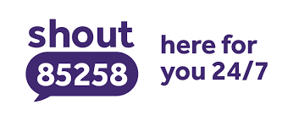
Shout is the UK’s first 24/7 text service, free on all major mobile networks, for anyone in crisis anytime, anywhere. It’s a place to go if you’re struggling to cope and you need immediate help. Text: 85258
Website: https://www.giveusashout.org/

AGE UK
Age Uk tackle loneliness, get older people active, and support people to stay independent for longer.
They put people in control of the care they receive, while sharing best practice to improve services. Age UK help millions of people to know their rights and make the best choices for later life.

Website: https://www.ageuk.org.uk/
Call Advice Line on: 0800 055 6112

2.2 Local Mental Health 24 Hr Helplines

Barnsley, Calderdale, Kirklees and Wakefield.
There is now a 24 hour mental health helpline for anyone registered with a GP in Barnsley, Calderdale, Kirklees and Wakefield. The service supports people who are: At risk of developing mental health problems, diagnosed with common mental health problems, accessing mental health support, experiencing mental health distress and/or seeking information, advice and support

You can now access this service on: 0800 183 0558.

If you do not receive any of the services and want to contact directly about either yourself or someone you know you can also use the numbers below.

Barnsley
In Barnsley 24/7 open access to mental health services:
Adults (aged 18+) – 01226 645000
Children and young people (CAMHS) – 01226 644829
People with a learning disability- 01226 645237

Calderdale
In Calderdale 24/7 open access to mental health services:
Adults (aged 18 +) – 01924 316830
Children and young people (CAMHS) – 01422 300001
People with a learning disability –– 07795 884879

Kirklees
In Kirklees 24/7 open access to mental health services:
Adults (aged 18-65) – 01924 316830
Older adults – 0300 304 5555
Children and young people (CAMHS) 0300 304 5555
People with a learning disability – 01924 316714

Wakefield
In Wakefield 24/7 open access to mental health services:
Adults (aged 18+) – 01924 316900
Children and young people (CAMHS) – 01977 735865
People with a learning disability – 01977 465435

Bradford
The First Response crisis service offers support 24 hours a day, seven days a week to people of all ages living in Bradford, Airedale, Wharfedale or Craven experiencing a mental health crisis.
Telephone: 0800 952 1181
Website: https://www.bdct.nhs.uk/services/first-response/
First response leaflet - https://www.bdct.nhs.uk/wp-content/uploads/2016/12/First-Response-concertina-leaflet-new-freephone-number.pdf

North Yorkshire

Crisis services for Children, working aged adults and older people. If you are experiencing difficulties with your mental health and would like some support, please contact one of the local services below:
Mental health services for social care support and assessments: 01609 780780
North Yorkshire mental health crisis support: 0800 0516 171
Helpline for those struggling with emotional wellbeing - Hear to help: 01423 856 799
Website : https://www.tewv.nhs.uk/services/crisisadvice/

Leeds
If you, or someone you’re worried about, needs urgent care or treatment for a mental health crisis call the Single Point of Access (SPA).
Freephone: 0800 183 1485 (open 24/7, every day).
You can speak to health care professionals who can refer you to specialist mental health services in Leeds.
Website : https://www.leedsandyorkpft.nhs.uk/advice-support/help-in-a-crisis/

2.3 Additional Websites
Leeds
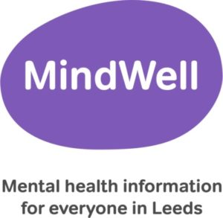
The MindWell website is the single ‘go to’ place for information about mental health in Leeds. It allows anyone living or working in Leeds, including GPs and other professionals, to get quick, easy and direct access to up-to-date mental health information.
Website : https://www.mindwell-leeds.org.uk/

Bradford
The Healthy Minds website is the single point of access for all in Bradford District and Craven to look after their minds. The website was created to bridge the gap between those looking for support and services struggling to reach and help the right people. Home to the Healthy Minds Wellbeing Assistant, Services Index and Wellbeing Resources, the website is easy to use, opening the door to mental health and wellbeing support services, resources and information.
Mind in Bradford delivers the website’s directory, which helps you to find support services via the Service Index or Wellbeing Assistant. The Services Index lists a wide range of wellbeing support services available in Bradford District and Craven, from workshops to peer support groups, and the Wellbeing Assistant offers tailored suggestions on services and self-help apps based on how the user is feeling, so people can find what they need, when they need it – quickly and easily.
Wellbeing resources cover a range of topics and provide self-help materials to help people understand and improve their thoughts and feelings.
Website : www.healthyminds.services

2.4 Downloadable Apps for support and self help

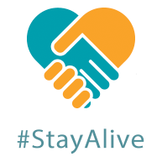
Stay Alive
The Stay Alive app is packed full of useful information and tools to help you stay safe in crisis. You can use it if you are having thoughts of suicide or if you are concerned about someone else who may be considering suicide. The app also links you directly to local and national crisis resources and if a resource isn’t listed, you can simply add in your own.
The app is available on Google Play and the iTunes App Store.

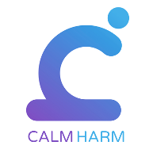
Calm Harm
Calm Harm is an app that provides tasks to help you resist or manage the urge to self-harm. You can make it private by setting a password, and personalise the app if you so wish. You will be able to track your progress and notice change.
The app is available on Google Play and the iTunes App Store and is also featured on the NHS apps library.
Both apps are free to download and while these are useful aids in treatment they should not replace it.

Every Mind Matters - Every Mind Matters can help with expert advice, practical tips and personalised actions to help stay on top of your mental health and wellbeing. You can also create a free personalised mind plan which is designed to help you feel more in control, deal with stress and anxiety, boost your mood and improve your sleep
Website : https://www.nhs.uk/every-mind-matters/

For Children and Young People - Think Ninja
ThinkNinja is a mental health app designed for 10-18 year olds. Using a variety of content and tools, it allows young people to learn about mental health and emotional well-being, and develop skills they can use to build resilience and stay well.

3. Support for survivors of Sexual Abuse and Church related abuse.

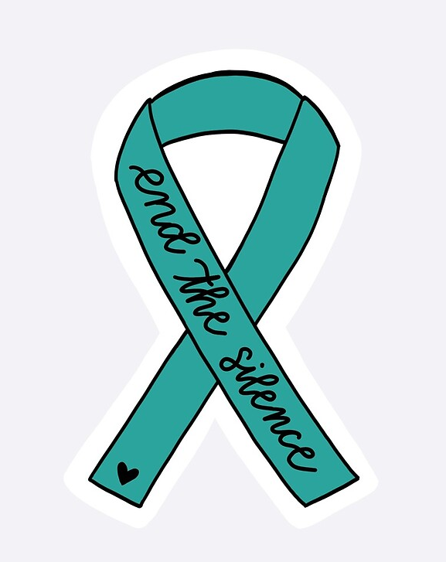

3.1 National Helplines and Support Agencies
Section 1. National Directories for accessing support, provides an extensive list of services that can accessed. Suggested services specifically aimed to support survivors of sexual abuse are listed below.

Sexual Assault Referral Centres (SARCs)
SARCs are specialist medical and forensic services for people who have been raped or sexually assaulted. Their services are free of charge and provided to women, men and children, regardless of whether the victim/ survivor wishes to report the offence to the police or not.
Local Sexual Assault Referral Centres can be found on the NHS website by searching a postcode or town here: https://www.nhs.uk/Service-Search/Rape-and-sexual-assault-referral-centres/LocationSearch/364
Independent Sexual Violence Advisers (ISVAs) ISVAs provide a range of specialist support to victims/ survivors to look after their needs. ISVAs can offer information about how the criminal justice system works, but there is no expectation that by contacting an ISVA a victim/ survivor will be expected to report any offence to the police. ISVAs can provide information to make sure victims/ survivors make the right decision for them. ISVAs are available at some SARCs and some other specialist support agencies.
More information about ISVAs and how to access them is available at the Survivors Trust website here: https://www.thesurvivorstrust.org/independent-sexual-violence-advisers
There are also Independent Domestic Violence Advisers (IDVAs) and those who specialise in both domestic and sexual violence (IDSVAs) available at some survivor support organisations.

The Survivors Trust
The Survivors Trust is an umbrella organisation with 129 member organisations based in the UK and Ireland which provide specialist support for women, men and children who have survived rape, sexual violence or childhood sexual abuse. The Survivors Trust also holds further information about SARCs and IDSVAs. On the Survivors Trust website, it is possible to search a postcode to find local support or to view services operating in a particular region. The Survivors Trust also holds information about services operating nationally.
This information is available here: https://www.thesurvivorstrust.org/find-support
Free helpline: 08088 010818

Survivors UK- Support for adult males
Survivors UK provides support to adult males who have experienced any form of sexual violence. They have web and text chat services as well as individual and group counselling in London.
Details are available here: https://www.survivorsuk.org/

Rape Crisis Helpline
Rape Crisis England & Wales is the umbrella body for a network of independent Rape Crisis Centres. All member Centres provide specialist support and services for victims and survivors of sexual violence. The helpline is open from 24 hours a day, every day of the year
Freephone Helpline: 0808 500 2222
Website: https://rapecrisis.org.uk/

Authorised Listening Service
The Diocese of Leeds has appointed Authorised Listeners, all of whom are available to meet with anyone who needs an attentive and attuned listening ear to help them to talk about current or past abuse of any nature.
What are Authorised Listeners?
They are church people, some lay, and some ordained, who have come forward to offer a listening service to survivors. They have backgrounds in pastoral work and have been specially recruited and trained for this role.
What do they do?
They will offer up to three sessions to meet you and hear what you have to say. It is for you to decide whether to meet, whether to meet again and to consider what the possible next steps may be. The listener will not impose any particular course of action on you. Further information can be found within the leaflet below.
Up to three sessions can be provided free of charge. If you would like to speak to a listener then please contact, the Leeds safeguarding team via email: safeguarding@leeds.anglican.org or telephone: 0113 353 0257.

3.2. Support for victims/ survivors of church related abuse

Safe Spaces -
Safe Spaces is delivered by First Light. First Light is an independent organisation with over 25 years’ experience in supporting those who have experienced or are experiencing sexual abuse and/or domestic violence and abuse, including survivors and victims of church-related abuse.
Monday to Friday 9am – 9pm
Saturday 9-1pm
Sunday 1-5pm
0300 303 1056
safespaces@firstlight.org.uk
https://www.safespacesenglandandwales.org.uk
Minister And Clergy Sexual Abuse Survivors (MACSAS)
MACSAS supports women and men who have been sexually abused, as children or adults, by ministers, clergy or other church officers. Their website offers useful resources and they also have a helpline for victims and survivors and their relatives.
Details are available here: https://www.macsas.org.uk/

3.3 Additional Resources:

From Report to Court is a downloadable handbook for adult survivors of sexual abuse and violence. It is produced by the organisation Rights of Women, but as the handbook focuses on the process of reporting sexual abuse all the way through to a criminal trial, it is usable by both men and women, and is available here: https://rightsofwomen.org.uk/wp-content/uploads/2019/03/From-Report-to-Court-2018.pdf
Help for Adult Victims of Child Abuse provide a number of resources, many of which are freely available and written by survivors for survivors. They are available here: https://www.havoca.org/resources/

The National Association for People Abused in Childhood (NAPAC) provides some online advice addressing common concerns that many survivors have, available here: https://napac.org.uk/common-concerns/
Telephone: 0808 801 0331
They also provide some freely-accessible reading on various topics for survivors here: https://napac.org.uk/resources/

Rape Crisis provide online advice for many issues and concerns experienced by survivors. Much of their advice is suitable for adult victims of child abuse, not just for adult victims of rape. Further information is available here: https://rapecrisis.org.uk/get-help/looking-for-tools-to-help-you-cope/

One-in-four provide a page full of resources focusing on support and self-care for survivors to download and work through at their own pace here: http://www.oneinfour.org.uk/support-self-care/

4. Support Agencies and Helplines for Victims/ Survivors of Domestic Abuse, Stalking and Harassment, Honour Based Violence and Forced Marriage.

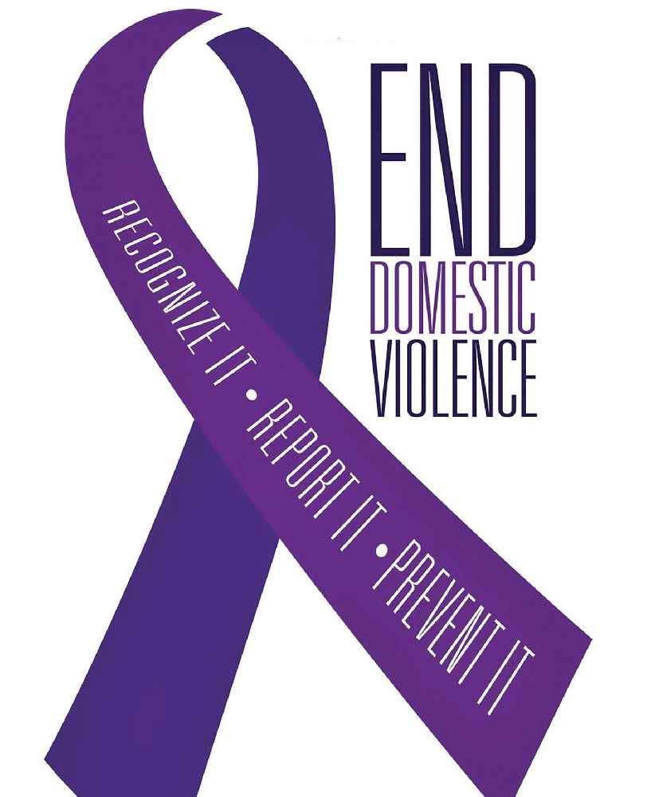

4.1 Organisations for women

National Domestic Abuse helpline - The National Domestic Abuse Helpline is a Freephone 24-hour helpline which provides advice and support to women and can refer them to emergency accommodation. The National Domestic Abuse Helpline is run by Refuge.
There are translation facilities if your first language is not English. The Helpline also offers BT Type talk for callers with hearing difficulties. The Helpline worker contacts the Type talk operator so that the caller can communicate through them.
Website: www.nationaldahelpline.org.uk
Telephone: 0808 2000 247

Refuge - Their helpline offers advice and support to women experiencing domestic violence.
Refuge also provide safe, emergency accommodation through a network of refuges throughout the UK, including culturally-specific services for women from minority ethnic communities and cultures.
Their website also includes some information for men who are either being abused or who are abusers.
Website: www.refuge.org.uk

Women's Aid - The Women's Aid website provides a wide range of resources to help women and young people. This includes The Survivor's Handbook https://www.womensaid.org.uk/information-support/the-survivors-handbook/ which provides a range of information including legal and housing advice, tips on how to create a safety plan and advice for people with specialist housing needs. It's available in 11 languages and in audio.
They also run a website to support to children and teenagers who may be living in a home affected by domestic violence, or who may be in a violent relationship themselves.
Website: https://www.womensaid.org.uk/
Please copy and paste the above links as the hyperlink will not work!

Rights of Women - Rights of Women offers confidential legal advice on domestic and sexual violence. You can find out more about what they do and when they’re open on their website.
Website: www.rightsofwomen.org.uk

Finding Legal Options for Women Survivors (FLOWS)- FLOWS gives legal advice to women who are affected by domestic abuse - they also give advice to front line workers.
Website: https://www.rcjadvice.org.uk/family/flows-finding-legal-options-for-women-survivors/

Southall Black Sisters - Southall Black Sisters provide advice for Black (Asian and African-Caribbean) women with issues including domestic abuse, forced marriage, immigration and homelessness.

Telephone : 0208 571 9595 , Monday to Friday 9:00 am – 5:00 pm
Website: www.southallblacksisters.org.uk

4.2 Organisations for men

Respect - Men's Advice Line - The Men's Advice Line is a confidential helpline for all men experiencing domestic violence by a current or ex-partner. They provide emotional support and practical advice, and can give you details of specialist services that can give you advice on legal, housing, child contact, mental health and other issues.
Website: www.mensadviceline.org.uk

ManKind Initiative- The ManKind Initiative is a charity offering information and support to men who are victims of domestic abuse or violence. This can include information and support on reporting incidents, police procedures, housing, benefits and injunctions. They can refer you to a refuge, local authority or other another support service if you need it.
Website: https://www.mankind.org.uk/

SurvivorsUK- This is a helpline for men who have been victims of rape or sexual abuse.
They may be able to arrange counselling or a support group if you live in the London area, or provide details of an appropriate service if you don't.
Website: www.survivorsuk.org

4.3 Organisations for Women and Men

RCJ Advice Family Service
RCJ Advice Family Service can give legal advice to people who are affected by domestic abuse or need family law help –
Website: https://www.rcjadvice.org.uk/family/

Rape Crisis - Rape Crisis (England and Wales) is an umbrella organisation for Rape Crisis Centres across England and Wales. The website has contact details for centres and gives basic information about rape and sexual violence for survivors, friends, family, students and professionals. Rape Crisis (England and Wales) also runs a freephone helpline.
Website: www.rapecrisis.org.uk
Telephone: 0808 500 2222

Honour Network Helpline
The Honour Network Helpline is a national helpline run by Karma Nirvana, a national charity which advises victims and survivors of forced marriage and honour-based abuse.
Website: www.karmanirvana.org.uk

Action on Elder Abuse
Action on Elder Abuse gives confidential advice and information to older people who are victims of violence or abuse. A relative or friend of the person being abused can also contact the helpline on behalf of the older person. The helpline can be used in the case of older people who live at home, in a care home or who are in hospital.
Website: www.elderabuse.org.uk
Telephone: 0808 808 8141 (free phone Monday to Friday 9-5pm)

Suzy Lamplugh Trust - National Stalking Helpline
The National Stalking Helpline can provide advice on how to deal with any type of stalking behaviour. This includes advice on how to report the behaviour to the police, and what you can expect if you report something.
Website : https://www.suzylamplugh.org/ Telephone: 020 7091 0014
Website: https://www.suzylamplugh.org/Pages/Category/national-stalking-helpline
Telephone : 0808 802 0300

Respect Phoneline
Respect Phoneline offers information and advice to partners, friends and family who want to stop someone's violent behaviour.
Website: www.respectphoneline.org.uk

4.4 Organisations for Lesbian, Gay, Bisexual and Transgender people.

National LGBT+ Domestic Abuse Helpline
A helpline for LGBT+ people who have or are experiencing domestic abuse. They also assist people who are supporting a survivor of domestic abuse; friends, families and those working with a survivor.
There are different ways to contact. All of them are free:
Phone 0800 9995428
Email help@galop.org.uk
The helpline is open: Monday to Friday 10am – 5pm, Wednesday and Thursday 10am – 8pm
Webchat : The webchat is available: Wednesday and Thursday 5pm – 8pm
0pen 5 days a week and closed at weekends and on bank holidays.
Chatbot: The chatbot is available 24 hours a day, 7 days a week for those who do not need immediate help

4.5 Organisations for individuals with disabilities.

SignHealth - Domestic Abuse Service
SignHealth provides a specialist domestic abuse service to help Deaf people find safety and security. You can find out how to contact them on their website.
Website: www.signhealth.org.uk/with-deaf-people/domestic-abuse/domestic-abuse-service/

Respond
Respond work with children and adults with learning disabilities who’ve either experienced abuse or abused other people.
Website: www.respond.org.uk

5. Support for Children and Young People

5.1 Support for Children and Young People

NSPCC - is the leading children’s charity in the UK, specialising in child protection and dedicated to protecting children and preventing abuse. They’re the only UK children’s charity with statutory powers, which means they can take action to safeguard children at risk of abuse.
Telephone: 0808 800 5000
Email: help@nspcc.org.uk
Website: https://www.nspcc.org.uk/

ChildLine - ChildLine is a private and confidential service for children and young people up to the age of nineteen. You can contact a ChildLine counsellor for free about anything - no problem is too big or too small.
Telephone: 0800 1111
Website: www.childline.org.uk

Youth Access Directory of services: YIACS are organisations rooted in local communities all over the country that provide free, easily accessible and age-appropriate support to young people aged 11-25 with a wide range of issues
Website : https://www.youthaccess.org.uk/services/find-your-local-service

Young Minds- Promoting good mental health to children and young people and includes a parents help line. The UK's leading charity championing the wellbeing and mental health of young people
Call: 0808 802 5544
Website: https://youngminds.org.uk/

The Mix - The Mix provides judgement-free information and support to young people aged 13-25 on a range of issues including mental health problems. Young people can access the The Mix's support via phone, email, webchat, peer to peer and counselling services.
Telephone: 0808 808 4994 (4pm-11pm, free to call, Monday to Saturday)
Crisis Support: Text 'THEMIX' to 85258.
Website: www.themix.org.uk/get-support

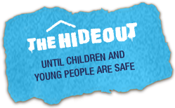
The Hideout – Children experiencing Domestic Abuse
Women's Aid have created this space to help children and young people to understand domestic abuse, and how to take positive action if it's happening to you. This website has a quick exit function.
Website: https://thehideout.org.uk/

CAMHS
Child and adolescent mental health service (CAMHS) help children and young people in the local area who may be having problems. They may be very upset or very angry, they may be behaving in unusual ways, or their family or carers, friends or teachers may be very worried about them. CAMHS supports children and young people from pre-school years up to 16 years of age, (or up to 18 years of age if still in school) where there are severe and long standing concerns about emotional well-being and behaviours.
If you think it would help to talk to somebody at CAMHS, a child, parent or guardian, will need to speak to someone such as a doctor or school nurse. They will then tell you what you need to do and what happens next.
Further information on CAMHS can be found at : https://youngminds.org.uk/find-help/your-guide-to-support/guide-to-camhs/

5.2 Additional Local Websites for Children and Young People

Leeds - MindMate –
MindMate is a Leeds-based website for young people, their families and the professionals who support them. If you are a young person, this website can give you useful tips and information on where to go for help, support and advice in Leeds.
If you are a parent or carer concerned or upset by a child’s or teenager’s behaviour, MindMate also has key resources and information to help you support your child. Advice is also available for young parents or young people who are expecting a baby and are struggling with their emotional wellbeing.
Website : https://www.mindmate.org.uk/im-a-young-person/

North Yorkshire – Compass Reach
Compass Reach is a free, confidential health and wellbeing service for children and young people aged 9 – 19 (and up to 25 for those with special educational needs or disabilities) who may benefit from receiving early help and prevention work in relation to mild to moderate emotional wellbeing and mental health issues.
Telephone: 01904 661916 or freephone number 0800 008 7452
Website: https://www.compass-uk.org/services/north-yorkshire-compass-reach/

Kirklees- Thriving Kirklees - Kooth
Kooth.com is an anonymous, online counselling and support services for children and young, people, assessable through mobile, tablet and desktop and free at the point of use. Its available for 10-19 year olds in Kirklees. Kooth is a confidential and anonymous way for Kirklees young people to gain support and guidance from qualified counsellors Its available up to 10 o’clock at night, 365 days a year.
Website : https://www.kooth.com/
Thriving Kirklees website: https://www.thrivingkirklees.org.uk/about-us/

