The 3 “R”s
When I went to school, we were all taught the three Rs – because back then they meant reading, (w)riting and (a)rithmetic. Today the term 3Rs means something very different. It is an environmental concept symbolising Reduce, Reuse and Recycle and is designed to give us a priority order of how we should deal with our household wastes, particularly with the used packaging generated in our daily lives.
As you can see from the diagram which is called a waste management hierarchy, the first priority must be to Reduce the amount of waste that we produce. Cutting out impulse buying of some products will help because often you don’t really need those products so they get thrown away whilst still usable. There are calls from some campaigning groups to reduce the amount of packaged goods that we buy to reduce the amount of used packaging. But be careful here. A major amount of food waste in supermarkets and at home comes from unpackaged produce. The packaging is there to protect and preserve the goods and extend their shelf life. An unwrapped cucumber can be inedible three days after you buy it; one wrapped with under one gram of shrink wrap will still be edible up to two weeks after purchase. Good packaging reduces food waste.
And what is also often not understood is that packaging manufacturers here in the UK are world leaders in reducing the thickness and weight of the packaging they supply. Typically, bottles, cans, tubs and trays are 30-50% lighter than they were 20 years ago. That means that the material and energy resources needed to make those packs has been reduced substantially - as has the amount of waste they produce.
After Reduce, the next priority in the hierarchy is Reuse. For many of my generation, the reusable glass bottle which was used for doorstep milk deliveries epitomises the idea of reuse of packaging. Many would love to see it come back to replace the plastic containers for the milk that we buy in the supermarket or corner store. But such a switch back would actually have a negative consequence for the environment. Scientific analyses have shown that glass bottles have to be returned for reuse up to 13 times to have the same environmental impact as the one trip plastic bottles they would replace. And unfortunately, the typical glass milk bottle is only returned about three times before it is broken or not returned into the milk delivery system.
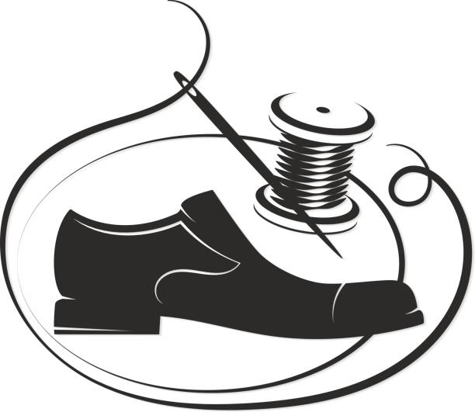
There are online sites such as freecycle.org which promote reuse of items. They help you give away usable items that they do not need any longer so that other people can Reuse them. And from small items such as shoes to major items including household appliances and even cars, Reuse can of course be facilitated by Repair and Restore - in many instances, repairing an item so it can be reused is environmentally far better than buying another new one. So perhaps we should have 5 Rs not just 3!
The next priority is Recycle. Over the last 20 years or so, most of us have become used to the council’s kerbside collection programmes for paper, card, cans, plastics and glass containers. Those used products are then sorted by material and sent for recycling either here or, unfortunately, overseas. Any materials recovered through recycling mean that less new materials have to be mined or pumped or otherwise extracted from the earth. But remember, recycling is an industrial process and has its own environmental impacts. So, it is important that we only recycle used products where the environment will benefit. Recycling is not always the best environmental option.
Having said that, most packaging today is made with substantial proportions of recycled materials, often 40-70% or even more - glass containers, cardboard boxes, cans and plastic bottles, produce and meat trays all use recycled materials. Real progress has been made in recent years on this significant environmental initiative.
When used products can’t or shouldn’t be recycled the next option in the hierarchy for the waste to be sent to one of the energy-from-waste (EFW) facilities in the area. There it is cleanly burned and the resulting heat used to generate enough electricity for tens of thousands of local homes on a 24/7 basis. This electricity replaces electricity which might otherwise be generated by coal, gas or nuclear power stations and supplements the electricity available from renewable resources – wind turbines and solar panels.
And finally, the last option for dealing with residual wastes is disposal to landfill. Happily, because of the growth of recycling and the use of EFW, the use of landfill as a waste management option has reduced sharply over recent years.
Whilst Britain has lots of landfill sites (e.g. old quarries converted to landfill sites), they are ugly, attract scavenging birds and methane is produced from any kitchen and other degradable wastes sent to the tip. This is a very powerful – and explosive – greenhouse gas and so landfill is the last option which should be considered today for most wastes.
In the future, we can expect that kitchen food wastes will be collected separately from other wastes from homes and restaurants and sent to facilities which convert those wastes into biogas and soil conditioners. At that point, even less of our wastes will have to be sent either to the EFW site or to landfill.
Back in the day, the three Rs were very important to schoolchildren. Today, different three Rs are important to all of society as we seek to care better for God’s creation.

David Eggelston
Christ Church, Harrogate

