REQUIRED TRAINING | Basic Awareness | Foundations | *Leadership | PtO Pathway | SRPM  (Recruitment) | RADA  (Domestic Abuse) | PSO
All church officers in any role | ✓
Those working with children and vulnerable adults | ✓ | ✓
PCC members | ✓ | ✓ |  |  |  | ✓
Churchwardens | ✓ | ✓ | ** |  |  | ✓
Parish Safeguarding Officers | ✓ | ✓ | ✓ |  | ✓ | ✓ | ✓
Readers | ✓ | ✓ | ✓ |  |  | ✓
Readers and Clergy with PtO | ✓ | ✓ |  | ✓ |  | ✓
Licensed Clergy | ✓ | ✓ | ✓ |  | ✓ | ✓
All involved in the recruitment of Church Officers (employees, elected members and volunteers) | ✓ | ✓ |  |  | ✓
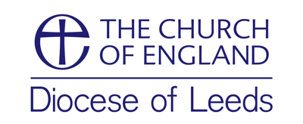
Basic Guidance for Training Requirements

*People also ‘required’ to undertake Leadership training include those who significantly influence the culture of any Church body. Such people may include, for example, lay ministry staff employed by a PCC or Bishops’ Mission Order, locally appointed leaders of new worshipping communities, focal ministers, and **Churchwardens, especially so if the responsibilities/duties of the Churchwarden have increased during a vacancy.

