Producing videos for your church doesn’t have to be difficult. In this guide we will cover the basics, including filming and uploading your video to social media platforms.

The Basics- Recording your Video
With the popularity of modern smartphones filming video has never been easier- if you have a smartphone you are carrying a video camera in your pocket. Tablets and many modern laptops also have built in webcams which allow you to record video. Below are the first things to think about when choosing where to record.
Things to consider when setting up to record:
- Lighting- are you well lit? Can people see you, or are you in shadow? Try and make sure you are not in front of a window- a well lit room with a neutral background, or somewhere quiet outside on a light day is best.
- Framing- can people see you? Make sure that the camera is pointed at you and you are in its frame.
- Volume- make sure you are fairly close to your phone so you can be heard. There are microphone options available, but your phone’s built-in microphone should be fine as long as you are close enough to it. If you are looking for a microphone for use with phones the microphone needs to have a 3.5mm headphone jack connector, and your phone needs to have the appropriate connection.
Now we need to decide how to record your video. If you are using a laptop or tablet the easiest thing to do is place it where its camera can see you and open your recording application. On tablets and phones this will be your ‘Camera’ app. On Windows laptops it will also be your Camera app, which can be found by searching ‘camera’ in the Windows search bar. On MacOS you will need to open Quicktime Player, found by search ‘Quicktime’ in the Spotlight search bar. Once Quicktime is open you then need to click ‘File’, ‘New Movie Recording’.

Phones also use their ‘Camera’ app to record video. However, it can be hard to place your phone to record your video while on your own, as they are small and may not stand on their own. If you have someone else who can record the video that will make life easier, or you can use a tripod. Phone tripods are available to buy on the internet, but you can also make your own with a plastic plant pot, coffee cup or similar. Simply turn your plastic holder over, and using scissors, cut a slit wide and deep enough for your phone to fit in. Place your phone in that gap and you have a quick and easy ‘tripod’ ready for your phone. You can also do the same thing with toilet paper tubes. See pictures below.
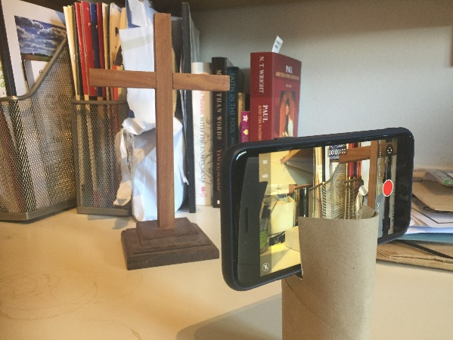

Once you’ve opened your recording app you should see a preview of the frame of video, which will allow you or your camera person to make sure your video will look ok, based on the things to consider above.
Now it’s time to record your video.

Making a Video
Making a video can be daunting. Robin Gamble, Bishop’s Advisor for Church Growth, has five areas to think about to help you decide what you want to achieve with your video, and how best to do so.
- Setting: think about what your background says to those watching. Try to make sure it suits the content you are making- should it be neutral, as not to distract the viewer, or should it have some flair to keep people’s interest?
- Appearance: think about what your appearance might say to those watching. Try to be deliberate in how you look- is your video meant to be casual, so you should look casual? Or are you being more serious, so a smarter look would be more appropriate? There are very few wrong answers, but try to make sure you’ve considered what you look like before you start.
- Style of video: should your video be longer or shorter, depending on what you are trying to say? Should it be high energy or more measured? What feels more natural to you? These are all questions you should consider when deciding on the style of your video.
- Content: when planning content, think about who the video is for. Is it for a church audience, or aimed at a wider group of people? This should affect how you share the message you want to share. You should also consider context and what’s going on in the world when deciding on content- it can help you work out what God might be calling you to say. Be prepared to film multiple takes of your video- everyone messes up from time to time, and with video you have the luxury of trying again, so take advantage of it!
- The Big Moment: try and make sure there is one thing in your video that, if nothing else, people remember. This should be the key message of your video- for example, you could use it to end well, and build to it. When planning your video make sure this message is in your mind, and frame the video around it.

Uploading your Video
So, you’ve filmed your video. Now it’s time to share it. Here we will show you how to upload videos to two of the big video sharing platforms, YouTube and Facebook.

Uploading videos to YouTube
The first step to uploading your video to YouTube is having a Google account. To do this open your internet browser and go to www.youtube.com or your YouTube app, then click or tap on the circle at the top right of the screen. There you will be able to log in to an existing Google account, or set up a new one by following the instructions after you click or tap ‘Create Account’. Once you have set up an account and/or logged in, you can upload your video.
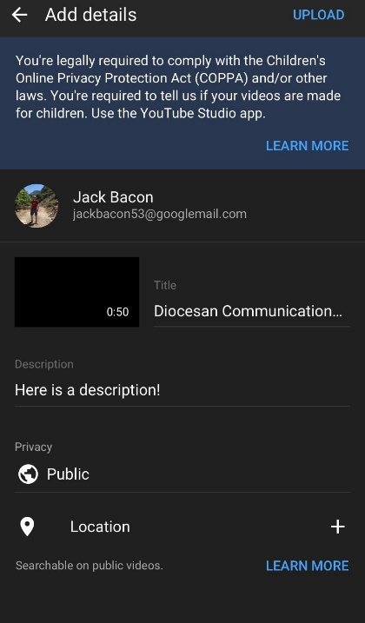
To upload from a phone: Tap on the little camera icon at the top of the screen, then select your video from your camera roll. Once it has finished preparing you will be able to trim it, before giving it a title and a short description. You can also then set privacy level for the video (public, where anyone can see it; unlisted, where only people with a link can see it; or private, where only you can see it). Then you hit upload in the top right hand corner, and you are done!
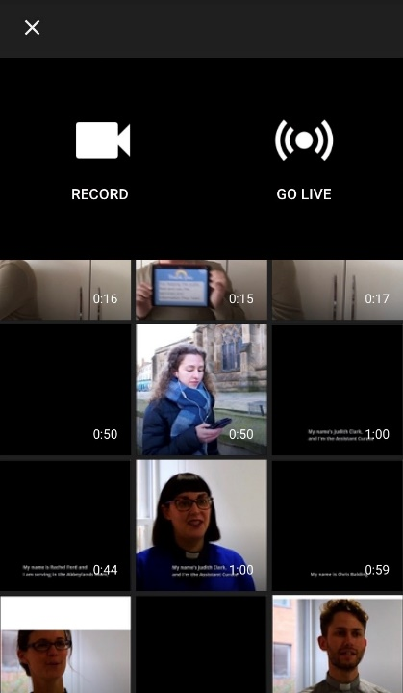
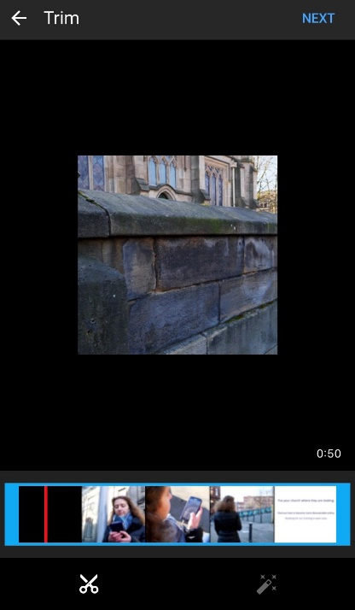
To upload from a computer: Click the little camera icon at the top right of the page. Then click ‘Select Files’ when it appears. This will open a window where you can locate your video file. Once you have found it, click on it and it will start uploading. Uploading from a computer gives you more options when uploading a video. A screen will appear allowing you to set a title, write a short description, choose a thumbnail image for your video, add your video to a playlist and choose whether it is a video made for kids. From there, click next to go to a page to add video elements (which will be mostly unnecessary for your video), then next again to go to a page where you can set your video privacy as said above, and also choose when the video goes ‘live’. On a computer you can choose to publish your video right away as on the phone, or schedule it to be published at a specific time. Then click save, and you are done!
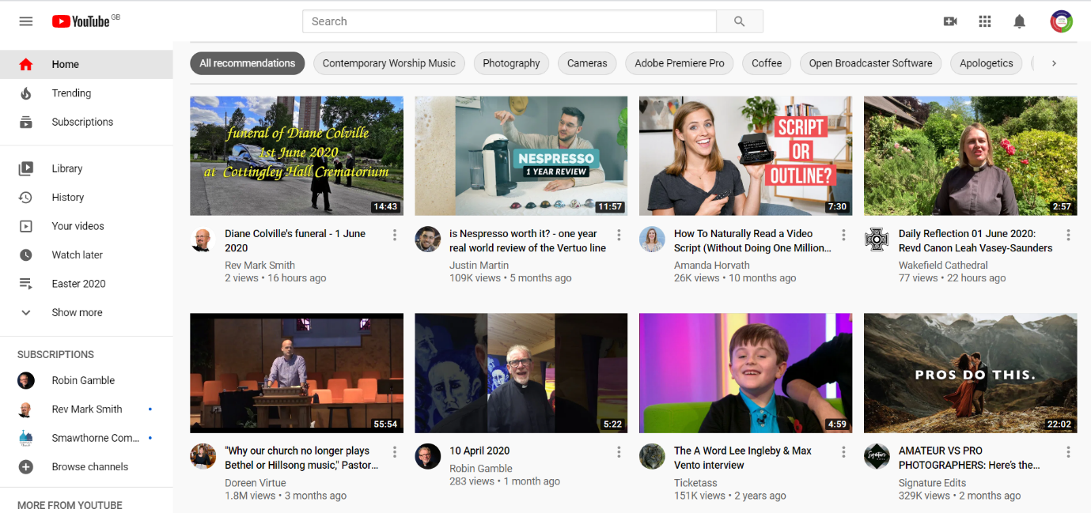
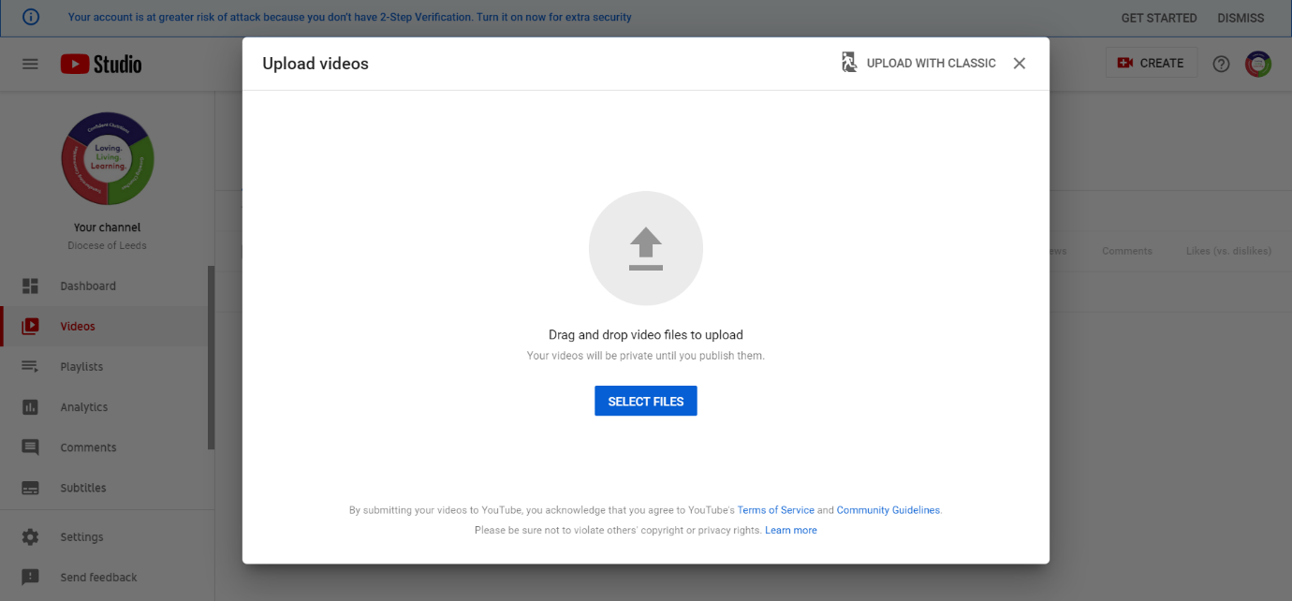
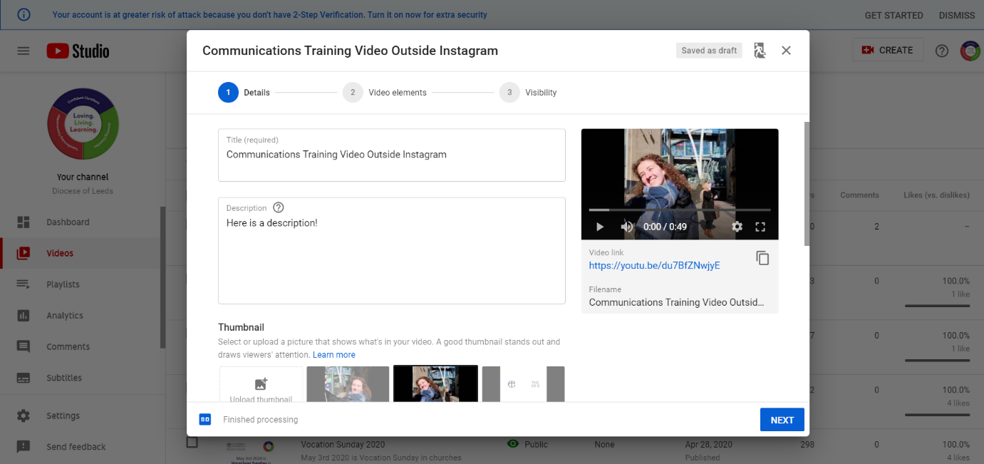
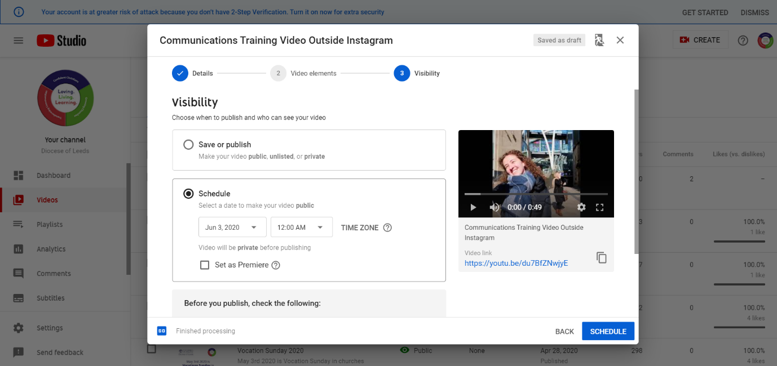

Uploading videos to Facebook
To upload to Facebook you need a Facebook account. This can be created on your phone, by downloading and opening the Facebook app, or on a computer, by using a browser to go to www.facebook.com. Follow the instructions in either of these places to set up our account. When uploading a video to Facebook you need to make sure you are putting it in the right place- specifically, your church’s Facebook page. To do this make sure you are an editor or admin of the page, then visit the page on your device.
To upload from a phone: When on your church’s page, tap the ‘Create a Post’ button. Tap the ‘Photo/Video’ button and choose the video from your camera roll. Give your video a title and a description, then tap the ‘Share’ button in the top right corner of the screen. The video is now published.
To upload from a computer: Go to your page, then click on the ‘Photo/Video’ button under the ‘Create Post’ button. This will open a window which will allow you to find where you have saved your video. Selecting your video will open another Facebook window with two tabs. On the first you can give your video a title, a description and tag it with appropriate tags (‘church’, ‘Christian’, ‘C of E’ etc). You can also choose the thumbnail, and also set up subtitles. If you would like subtitles the autogenerated ones are a good place to start, which is done by selecting a language and then clicking ‘Autogenerate’. You will then need to review them manually, which is done by clicking the ‘Review’ button next to ‘Added Captions’. Then you can go onto the ‘Publishing Options’ page by clicking ‘Next’. This page will allow you to choose when the video is published, which can be immediately or at a scheduled time. You can also change other settings here, but you should not have to. Then click ‘Publish’, and you are done.
